**OPERATING SYSTEMS**

**ASSIGNMENT 7**

**NAME : T Karthikeyan**

**ROLL : CED18I064**

**All my codes can be found here** [**CLICK HERE**](https://drive.google.com/drive/folders/15f8z17wcV-QzQxj6ZXuyNx5mlu_vCB52?usp=sharing)

**1. Simulate the Producer Consumer code discussed in the class.**

**Logic**

*Producer Consumer*

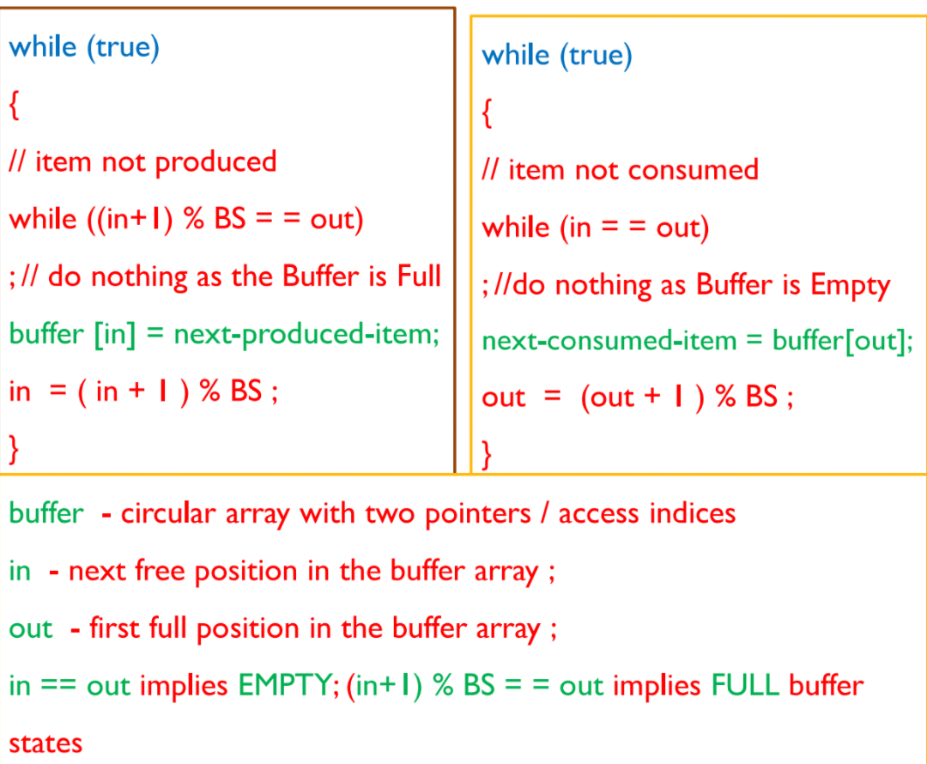

**Code**

**#include<stdio.h>**

**#include<stdlib.h>**

**#include<pthread.h>**

**#include<time.h>**

**#define BS 5**

**int in = 0;**

**int out = 0;**

**int buffer[BS];**

**void *producer(void *param)**

**{**

**int next_produced_item;**

**while(1)**

**{**

**next_produced_item = rand()%1000;**

**while((in+1)%BS == out); //do nothing as buffer is full**

**buffer[in] = next_produced_item;**

**in = (in+1)%BS;**

**printf("<producer> Produced Item : %d\n", next_produced_item);**

**printf("<producer> Buffer : %d %d %d %d %d in : %d out : %d\n", buffer[0], buffer[1], buffer[2], buffer[3], buffer[4], in, out); //why not for loop? To make the operation atomic**

**printf("\n");**

**sleep(2);**

**}**

**pthread_exit(0);**

**}**

**void *consumer(void *param)**

**{**

**int next_consumed_item;**

**while(1)**

**{**

**while(in == out); //do nothing as buffer is empty**

**next_consumed_item = buffer[out];**

**out = (out+1)%BS;**

**printf("<consumer> Consumed Item : %d\n", next_consumed_item);**

**printf("<consumer> Buffer : %d %d %d %d %d in : %d out : %d\n", buffer[0], buffer[1], buffer[2], buffer[3], buffer[4], in, out); //why not for loop? To make the operation atomic**

**printf("\n");**

**sleep(3);**

**}**

**pthread_exit(0);**

**}**

**int main(int argc, char *argv[])**

**{**

**int in, out;**

**in = 0;**

**out = 0;**

**srand(time(0));**

**pthread_t pid, cid;**

**pthread_attr_t attr1, attr2;**

**pthread_attr_init(&attr1);**

**pthread_attr_init(&attr2);**

**pthread_create(&pid, &attr1, producer, NULL);**

**pthread_create(&cid, &attr2, consumer, NULL);**

**pthread_join(pid, NULL);**

**pthread_join(cid, NULL);**

**return 0;**

**}**

**Output**

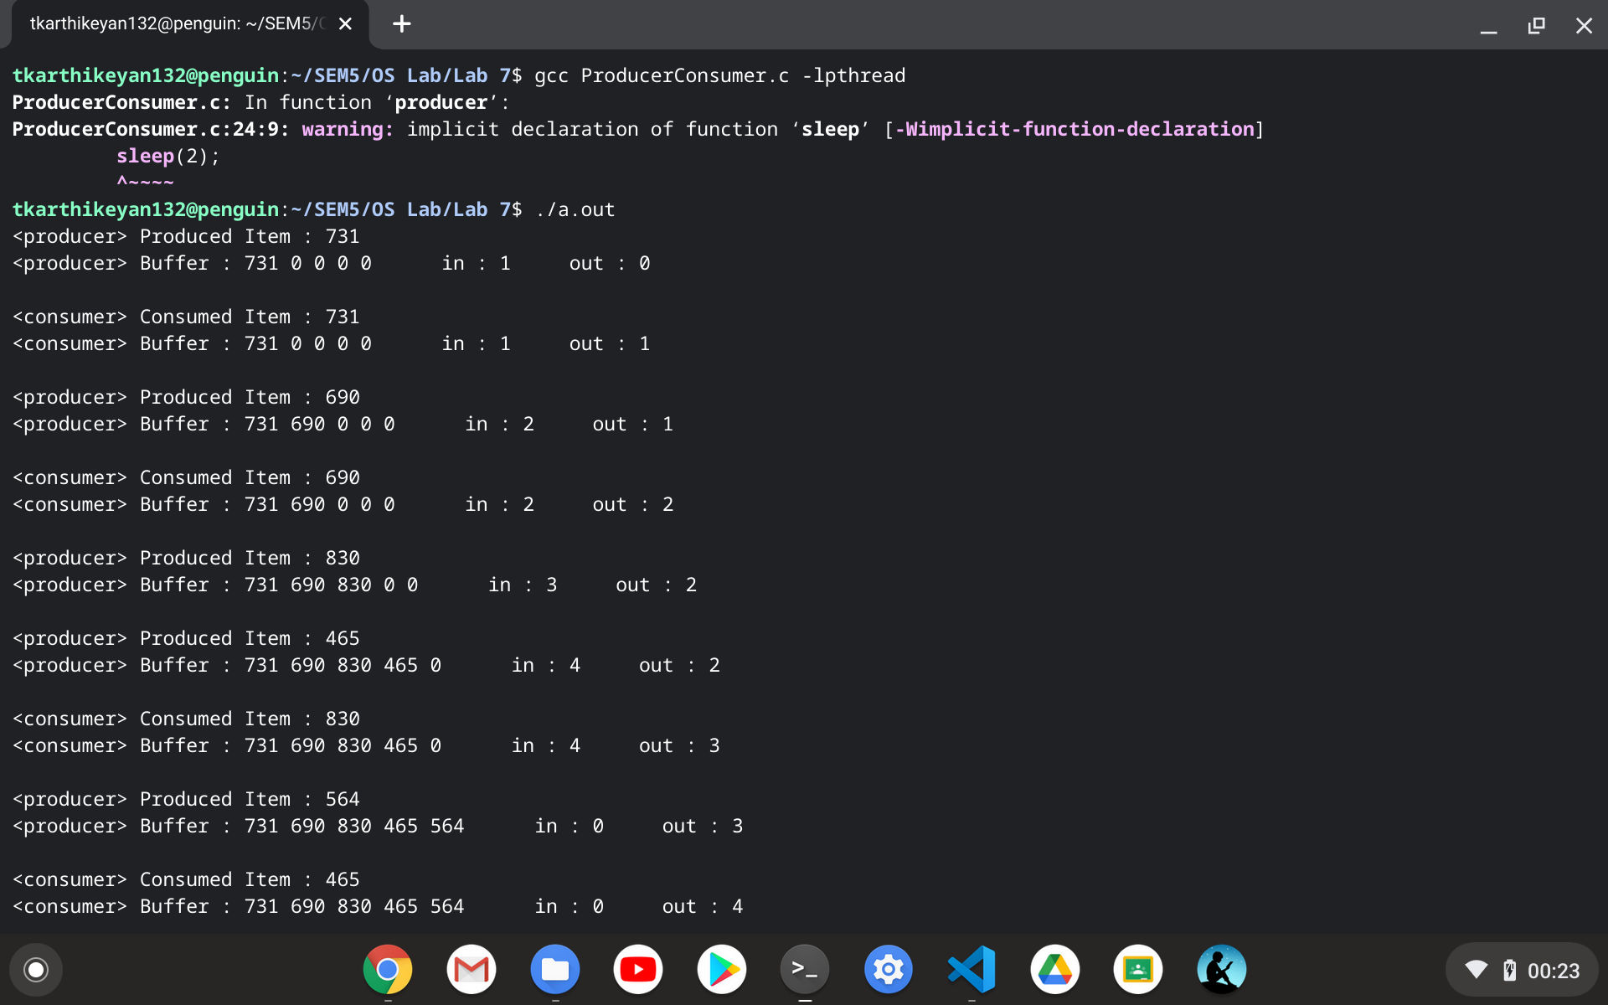

**2. Extend the producer consumer simulation in Q1 to sync access of critical data using Peterson's algorithm.**

**Logic**

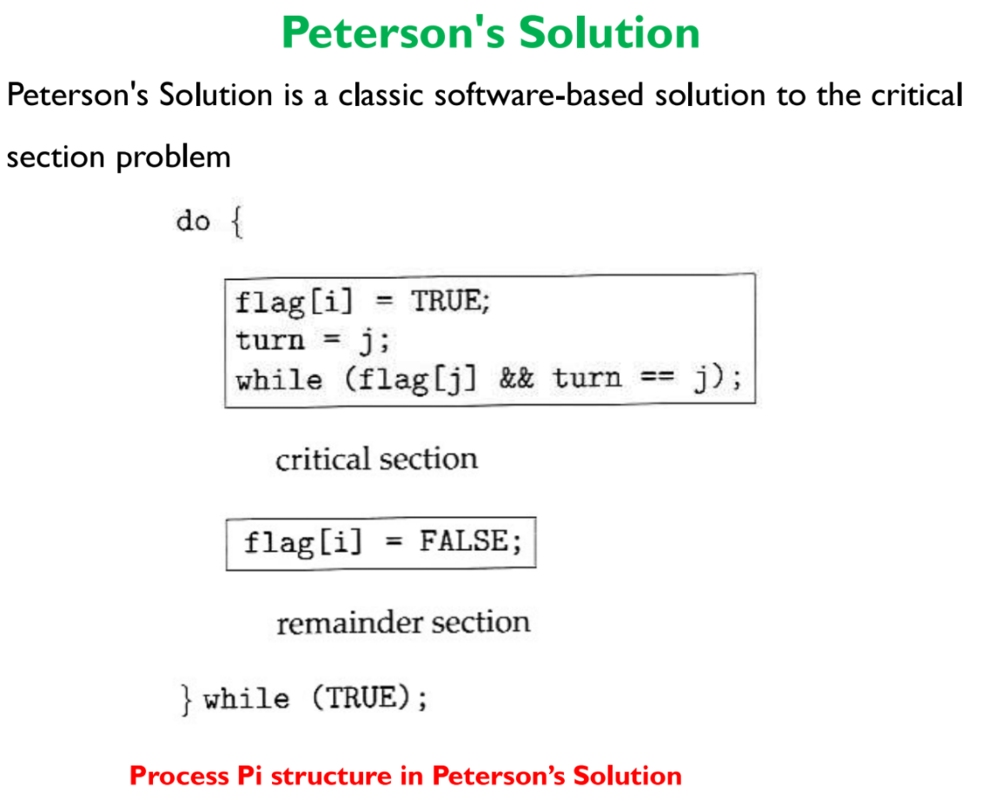

**Code**

**#include<stdio.h>**

**#include<stdlib.h>**

**#include<stdbool.h>**

**#include<pthread.h>**

**#include<time.h>**

**#define BS 5**

**int in = 0;**

**int out = 0;**

**int buffer[BS];**

**//0:Producer**

**//1:Consumer**

**//flag[i] = true implies P'i wants to enter critical section**

**bool flag[2] = {false, false};**

**//turn = i implies P'i turn**

**int turn = -1;**

**void *producer(void *param)**

**{**

**do**

**{**

**int next_produced_item;**

**flag[0] = true;**

**turn = 1;**

**//being humble towards consumer**

**while(flag[1] && turn == 1);**

**//critical section begins**

**next_produced_item = rand()%1000;**

**while((in+1)%BS == out); //do nothing as buffer is full**

**buffer[in] = next_produced_item;**

**in = (in+1)%BS;**

**printf("<producer> Produced Item : %d\n", next_produced_item);**

**printf("<producer> Buffer : %d %d %d %d %d in : %d out : %d\n", buffer[0], buffer[1], buffer[2], buffer[3], buffer[4], in, out); //why not for loop? To make the operation atomic**

**printf("\n");**

**sleep(1);**

**//critical section ends**

**flag[0] = false;**

**} while (true);**

**pthread_exit(0);**

**}**

**void *consumer(void *param)**

**{**

**do**

**{**

**int next_consumed_item;**

**flag[1] = true;**

**turn = 0;**

**//being humble towards producer**

**while(flag[0] && turn == 0);**

**//critical section begins**

**while(in == out); //do nothing as buffer is empty**

**next_consumed_item = buffer[out];**

**out = (out+1)%BS;**

**printf("<consumer> Consumed Item : %d\n", next_consumed_item);**

**printf("<consumer> Buffer : %d %d %d %d %d in : %d out : %d\n", buffer[0], buffer[1], buffer[2], buffer[3], buffer[4], in, out); //why not for loop? To make the operation atomic**

**printf("\n");**

**sleep(3);**

**//critical section ends**

**flag[1] = false;**

**} while (true);**

**pthread_exit(0);**

**}**

**int main(int argc, char *argv[])**

**{**

**srand(time(0));**

**pthread_t pid, cid;**

**pthread_attr_t attr1, attr2;**

**pthread_attr_init(&attr1);**

**pthread_attr_init(&attr2);**

**pthread_create(&pid, &attr1, producer, NULL);**

**pthread_create(&cid, &attr2, consumer, NULL);**

**pthread_join(pid, NULL);**

**pthread_join(cid, NULL);**

**return 0;**

**}**

**Output**

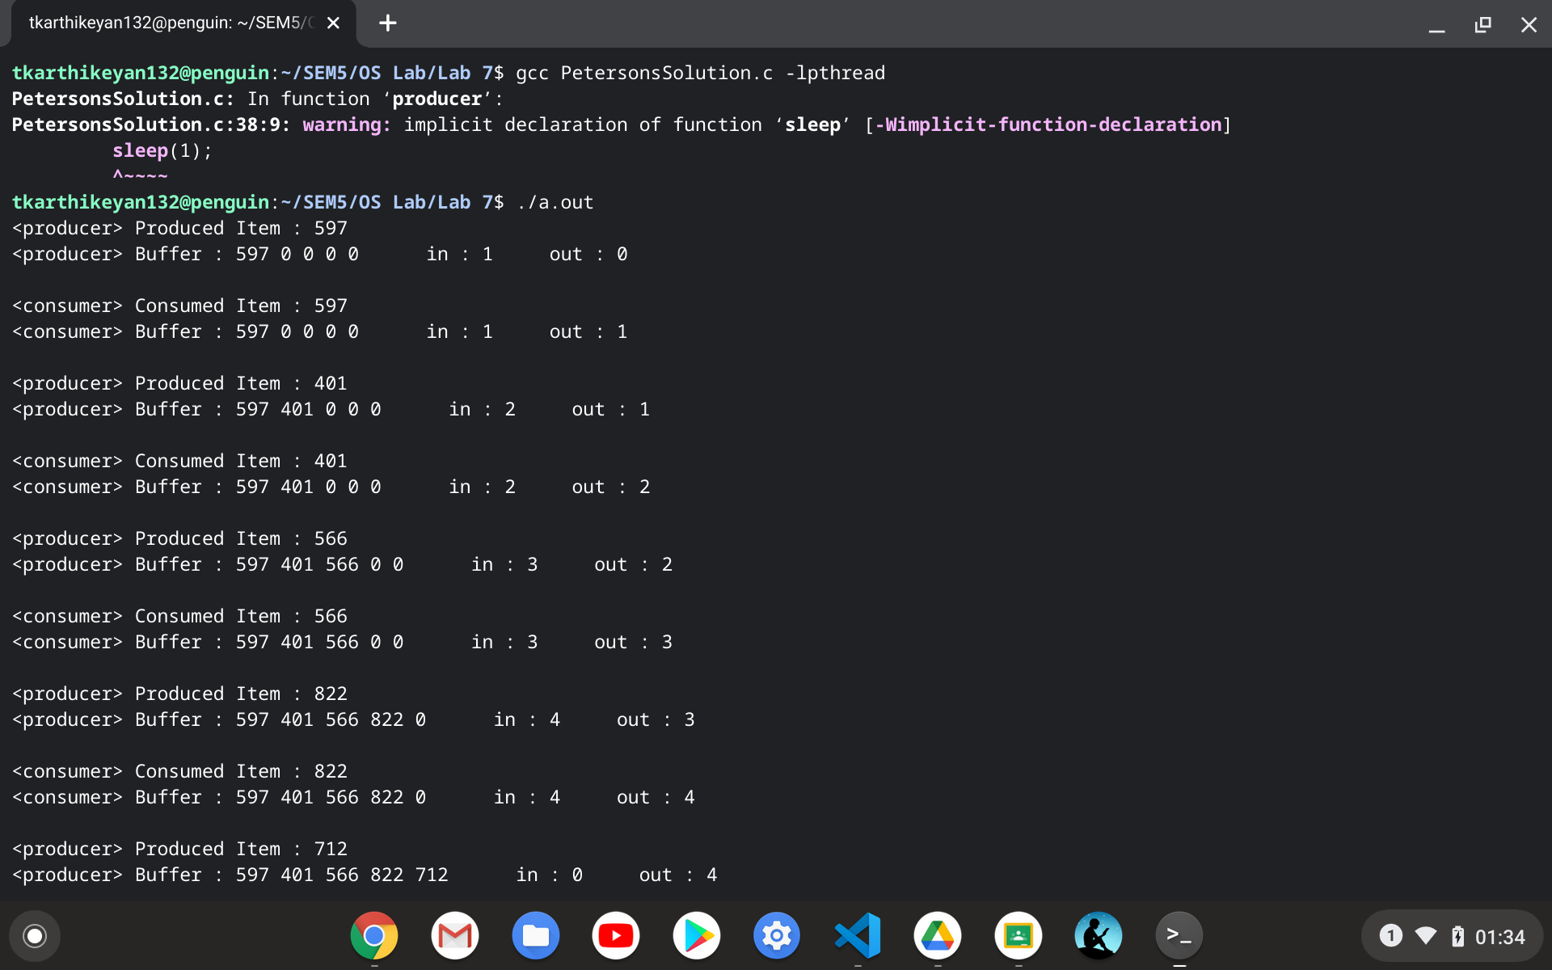

**3. Dictionary Problem: Let the producer set up a dictionary of at least 20 words with three attributes**

**(Word, Primary meaning, Secondary meaning) and let the consumer search for the word and retrieve its respective primary and secondary meaning.**

**Note: This can be implemented using either Mutex locks or Peterson's algorithm.**

**Logic**

*Dictionary is created using peterson's solution for synchronization*

*Linear Search is applied for searching*

**Code**

**#include<stdio.h>**

**#include<stdlib.h>**

**#include<stdbool.h>**

**#include<pthread.h>**

**#include<time.h>**

**#include<string.h>**

**#define DICT_LIM 20**

**int NUM_WORDS = 0; //number of words in dictionary**

**struct word**

**{**

**char word[25];**

**char meaning1[100];**

**char meaning2[100];**

**};**

**struct word W[DICT_LIM];**

**//0:Producer**

**//1:Consumer**

**//flag[i] = true implies P'i wants to enter critical section**

**bool flag[2] = {false, false};**

**//turn = i implies P'i turn**

**int turn = -1;**

**void *producer(void *param)**

**{**

**do**

**{**

**flag[0] = true;**

**turn = 1;**

**//being humble towards consumer**

**while(flag[1] && turn == 1);**

**//critical section begins**

**if(NUM_WORDS == DICT_LIM)**

**printf("Dictionary is full\n");**

**else**

**{**

**char w[25];**

**char mean1[100];**

**char mean2[100];**

**printf("<producer>\n");**

**printf("Enter the word : ");**

**gets(w);**

**printf("Enter the meaning 1 : ");**

**gets(mean1);**

**printf("Enter the meaning 2 : ");**

**gets(mean2);**

**strcpy(W[NUM_WORDS].word, w);**

**strcpy(W[NUM_WORDS].meaning1, mean1);**

**strcpy(W[NUM_WORDS].meaning2, mean2);**

**NUM_WORDS++;**

**}**

**//critical section ends**

**flag[0] = false;**

**} while (true);**

**pthread_exit(0);**

**}**

**void *consumer(void *param)**

**{**

**do**

**{**

**flag[1] = true;**

**turn = 0;**

**//being humble towards producer**

**while(flag[0] && turn == 0);**

**//critical section begins**

**if(NUM_WORDS == 0)**

**printf("Dictionary is empty\n");**

**else**

**{**

**char w[25];**

**int flag = -1;**

**printf("<consumer>\n");**

**printf("Enter the word to be searched : ");**

**gets(w);**

**for(int i = 0; i < NUM_WORDS; i++)**

**{**

**if(strcmp(w,W[i].word) == 0)**

**{**

**printf("primary meaning : %s\n", W[i].meaning1);**

**printf("secondary meaning : %s\n", W[i].meaning2);**

**flag = 0;**

**break;**

**}**

**}**

**if(flag)**

**printf("Requested word not found\n");**

**}**

**//critical section ends**

**flag[1] = false;**

**} while (true);**

**pthread_exit(0);**

**}**

**int main(int argc, char *argv[])**

**{**

**pthread_t pid, cid;**

**pthread_attr_t attr1, attr2;**

**pthread_attr_init(&attr1);**

**pthread_attr_init(&attr2);**

**pthread_create(&pid, &attr1, producer, NULL);**

**pthread_create(&cid, &attr2, consumer, NULL);**

**pthread_join(pid, NULL);**

**pthread_join(cid, NULL);**

**return 0;**

**}**

**Output**

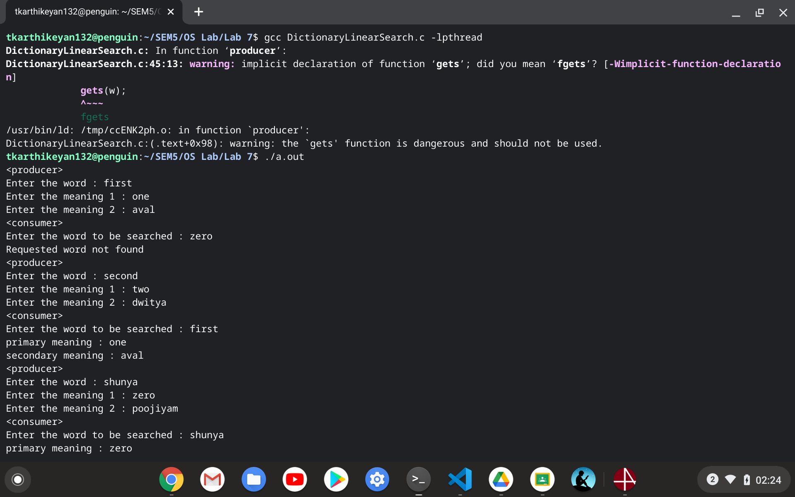

**Non-Mandatory (Extra credits):**

**4. Extend Q3 to avoid duplication of dictionary entries and implement an efficient binary search on the consumer side in a multithreaded fashion.**

**Logic**

*Dictionary is created using peterson's solution for synchronization*

*Binary Search is applied for searching*

*Binary search is used before inserting in dictionary to avoid duplication*

**Code**

**#include<stdio.h>**

**#include<stdlib.h>**

**#include<stdbool.h>**

**#include<pthread.h>**

**#include<time.h>**

**#include<string.h>**

**#define DICT_LIM 20**

**int NUM_WORDS = 0; //number of words in dictionary**

**struct word**

**{**

**char word[25];**

**char meaning1[100];**

**char meaning2[100];**

**};**

**struct word W[DICT_LIM];**

**//0:Producer**

**//1:Consumer**

**//flag[i] = true implies P'i wants to enter critical section**

**bool flag[2] = {false, false};**

**//turn = i implies P'i turn**

**int turn = -1;**

**struct block**

**{**

**char word_to_be_searched[25];**

**int beg;**

**int end;**

**int flag;**

**};**

**struct block_check**

**{**

**char word_to_be_searched[25];**

**int beg;**

**int end;**

**int flag;**

**};**

**void *search(void *param)**

**{**

**struct block *b = param;**

**for(int i = b->beg; i <= (b->end); i++)**

**{**

**if(strcmp(b->word_to_be_searched,W[i].word) == 0)**

**{**

**printf("primary meaning : %s\n", W[i].meaning1);**

**printf("secondary meaning : %s\n", W[i].meaning2);**

**b->flag = 0;**

**break;**

**}**

**}**

**}**

**void *search_check(void *param)**

**{**

**struct block_check *b = param;**

**for(int i = b->beg; i <= (b->end); i++)**

**{**

**if(strcmp(b->word_to_be_searched,W[i].word) == 0)**

**{**

**printf("Word already exists in the dictionary\n");**

**printf("primary meaning : %s\n", W[i].meaning1);**

**printf("secondary meaning : %s\n", W[i].meaning2);**

**b->flag = 0;**

**break;**

**}**

**}**

**}**

**void *producer(void *param)**

**{**

**do**

**{**

**flag[0] = true;**

**turn = 1;**

**//being humble towards consumer**

**while(flag[1] && turn == 1);**

**//critical section begins**

**if(NUM_WORDS == DICT_LIM)**

**printf("Dictionary is full\n");**

**else**

**{**

**char w[25];**

**char mean1[100];**

**char mean2[100];**

**printf("<producer>\n");**

**printf("Enter the word : ");**

**gets(w);**

**pthread_t aid, bid;**

**pthread_attr_t attra, attrb;**

**pthread_attr_init(&attra);**

**pthread_attr_init(&attrb);**

**int mid = NUM_WORDS/2;**

**struct block_check x, y;**

**strcpy(x.word_to_be_searched, w);**

**strcpy(y.word_to_be_searched, w);**

**x.beg = 0;**

**x.end = mid - 1;**

**y.beg = mid;**

**y.end = NUM_WORDS - 1;**

**x.flag = 1;**

**y.flag = 1;**

**pthread_create(&aid, &attra, search_check, &x);**

**pthread_create(&bid, &attrb, search_check, &y);**

**pthread_join(aid, NULL);**

**pthread_join(bid, NULL);**

**if(x.flag && y.flag)**

**{**

**printf("Enter the meaning 1 : ");**

**gets(mean1);**

**printf("Enter the meaning 2 : ");**

**gets(mean2);**

**strcpy(W[NUM_WORDS].word, w);**

**strcpy(W[NUM_WORDS].meaning1, mean1);**

**strcpy(W[NUM_WORDS].meaning2, mean2);**

**NUM_WORDS++;**

**}**

**}**

**//critical section ends**

**flag[0] = false;**

**} while (true);**

**pthread_exit(0);**

**}**

**void *consumer(void *param)**

**{**

**do**

**{**

**flag[1] = true;**

**turn = 0;**

**//being humble towards producer**

**while(flag[0] && turn == 0);**

**//critical section begins**

**if(NUM_WORDS == 0)**

**printf("Dictionary is empty\n");**

**else**

**{**

**char w[25];**

**printf("<consumer>\n");**

**printf("Enter the word to be searched : ");**

**gets(w);**

**pthread_t pid, qid;**

**pthread_attr_t attrp, attrq;**

**pthread_attr_init(&attrp);**

**pthread_attr_init(&attrq);**

**int mid = NUM_WORDS/2;**

**struct block p, c;**

**strcpy(p.word_to_be_searched, w);**

**strcpy(c.word_to_be_searched, w);**

**p.beg = 0;**

**p.end = mid;**

**c.beg = mid + 1;**

**c.end = NUM_WORDS - 1;**

**p.flag = 1;**

**c.flag = 1;**

**pthread_create(&pid, &attrp, search, &p);**

**pthread_create(&qid, &attrq, search, &c);**

**pthread_join(pid, NULL);**

**pthread_join(qid, NULL);**

**if(p.flag && c.flag)**

**printf("Requested word not found\n");**

**}**

**//critical section ends**

**flag[1] = false;**

**} while (true);**

**pthread_exit(0);**

**}**

**int main(int argc, char *argv[])**

**{**

**pthread_t pid, cid;**

**pthread_attr_t attr1, attr2;**

**pthread_attr_init(&attr1);**

**pthread_attr_init(&attr2);**

**pthread_create(&pid, &attr1, producer, NULL);**

**pthread_create(&cid, &attr2, consumer, NULL);**

**pthread_join(pid, NULL);**

**pthread_join(cid, NULL);**

**return 0;**

**}**

**Output**

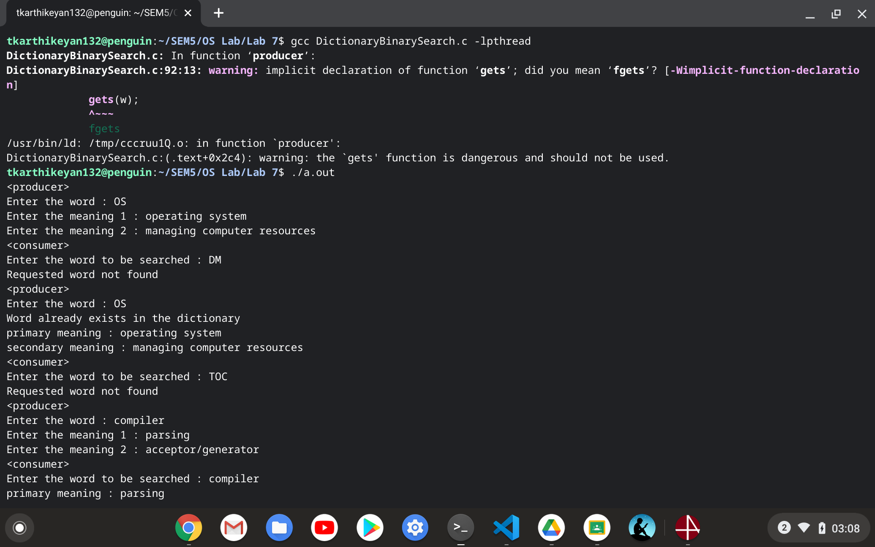

**5. Trace and understand the working of synchronization algorithms like Dijkstra, Dekker’s algorithm**

**DEKKERs ALGORITHM**

*Idea is to use favoured thread notion to determine entry to the critical section. Favoured thread alternates between the thread providing mutual exclusion and avoiding deadlock, indefinite postponement or lockstep synchronization.*

**CODE**

**#include<stdio.h>**

**#include<stdlib.h>**

**#include<stdbool.h>**

**#include<pthread.h>**

**bool thread1_wants_to_enter = false;**

**bool thread2_wants_to_enter = false;**

**int favoured_thread = 1;**

**int data = 0;**

**void *runner1(void *param);**

**void *runner2(void *param);**

**int main()**

**{**

**pthread_t tid[2];**

**int ttid[2] = {1,2};**

**pthread_create(&tid[0], NULL, runner1, &ttid[0]);**

**pthread_create(&tid[1], NULL, runner2, &ttid[1]);**

**pthread_join(tid[0], NULL);**

**pthread_join(tid[1], NULL);**

**return 0;**

**}**

**void *runner1(void *param)**

**{**

**do**

**{**

**thread1_wants_to_enter = true;**

**while(thread2_wants_to_enter == true)**

**{**

**if(favoured_thread == 2)**

**{**

**thread1_wants_to_enter = false;**

**}**

**while(favoured_thread == 2); // busy waiting**

**thread1_wants_to_enter = true;**

**}**

**//critical section starts**

**printf("<thread1>data : %d\n", data);**

**sleep(3);**

**//critical section ends**

**favoured_thread = 2;**

**thread1_wants_to_enter = false;**

**} while (1);**

**}**

**void *runner2(void *param)**

**{**

**do**

**{**

**thread2_wants_to_enter = true;**

**while(thread1_wants_to_enter == true)**

**{**

**if(favoured_thread == 1)**

**{**

**thread2_wants_to_enter = false;**

**}**

**while(favoured_thread == 1); // busy waiting**

**thread2_wants_to_enter = true;**

**}**

**//critical section starts**

**printf("<thread2>data : %d\n", data);**

**printf("<thread2>adding 1 to data\n");**

**data++;**

**printf("<thread2>incremented data : %d\n", data);**

**sleep(3);**

**//critical section ends**

**favoured_thread = 1;**

**thread2_wants_to_enter = false;**

**} while (1);**

**}**

**OUTPUT**

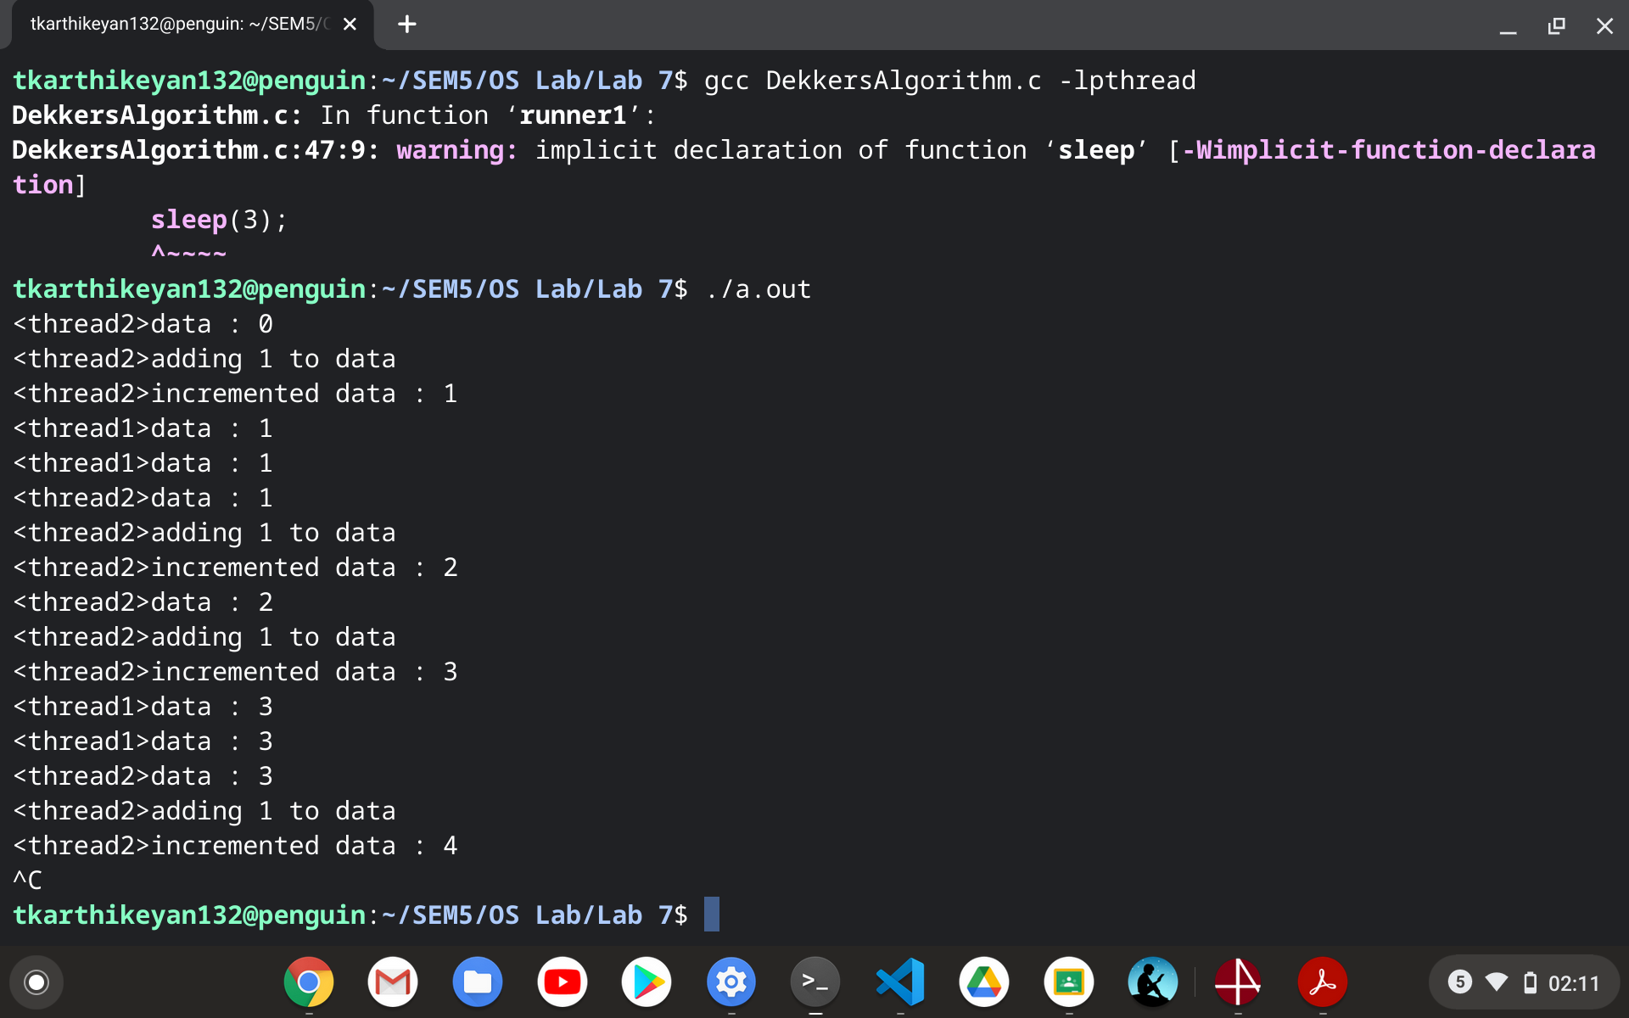

**--------------------------------------------------------------------------------------------------------------------------------------------------------------------------------------------------------------------------------------------------**

**LATIN MODULE**

1. **Latin Generator**

**CODE**

**#include <pthread.h>**

**#include <stdio.h>**

**#include <stdlib.h>**

**#include <unistd.h>**

**#include <string.h>**

**#include <sys/types.h>**

**#include <sys/wait.h>**

**#include <math.h>**

**#include <time.h>**

**struct block**

**{**

**int **arr;**

**int n;**

**int resp;**

**};**

**void *runner(void *param)**

**{**

**struct block *b = param;**

**int temp = b->resp;**

**int index = b->resp - 1;**

**int n = b->n;**

**for(int i = 0; i < b->n; i++)**

**{**

**b->arr[index][i] = temp;**

**temp++;**

**if(temp == (n+1))**

**temp = 1;**

**}**

**pthread_exit(0);**

**}**

**int main()**

**{**

**int n;**

**printf("Enter the degree of the matrix : ");**

**scanf("%d", &n);**

**int **arr = malloc(sizeof(int *)*n);**

**for(int i = 0; i < n; i++)**

**arr[i] = malloc(sizeof(int)*n);**

**struct block b[n];**

**for(int i = 0; i < n; i++)**

**{**

**b[i].arr = arr;**

**b[i].n = n;**

**b[i].resp = i+1;**

**}**

**pthread_t tid[n];**

**pthread_attr_t attr[n];**

**for(int i = 0; i < n; i++)**

**pthread_attr_init(&attr[i]);**

**for(int i = 0; i < n; i++)**

**{**

**pthread_create(&tid[i], &attr[i], runner, &b[i]);**

**}**

**for(int i = 0; i < n; i++)**

**{**

**pthread_join(tid[i], NULL);**

**}**

**for(int i = 0; i < n; i++)**

**{**

**for(int j = 0; j < n; j++)**

**printf("%d ",arr[i][j]);**

**printf("\n");**

**}**

**return 0;**

**}**

**OUTPUT**

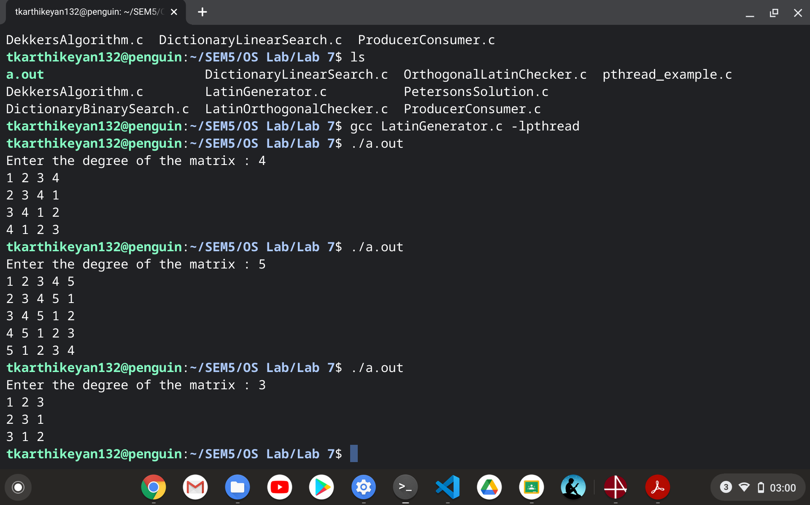

1. **Latin Orthogonal Checker**

**CODE**

**#include <pthread.h>**

**#include <stdio.h>**

**#include <stdlib.h>**

**#include <unistd.h>**

**#include <string.h>**

**#include <sys/types.h>**

**#include <sys/wait.h>**

**#include <math.h>**

**#include <time.h>**

**struct block**

**{**

**int **orr;**

**int x;**

**int y;**

**};**

**void *runner(void *param)**

**{**

**struct block *b = param;**

**b->orr[b->x][b->y] = 1;**

**}**

**_Bool isOrthogonal(int **orr, int n) // can be parallelised**

**{**

**for(int i = 0; i < n; i++)**

**{**

**for(int j = 0; j < n; j++)**

**{**

**if(orr[i][j] != 1)**

**return 0;**

**}**

**}**

**return 1;**

**}**

**int main()**

**{**

**int n;**

**printf("Enter the degree of the matrix : ");**

**scanf("%d", &n);**

**int **arr = malloc(sizeof(int *)*n);**

**for(int i = 0; i < n; i++)**

**arr[i] = malloc(sizeof(int)*n);**

**printf("Enter Matrix 1 (row-wise) : ");**

**for(int i = 0; i < n; i++)**

**for(int j = 0; j < n; j++)**

**scanf("%d", &arr[i][j]);**

**int **brr = malloc(sizeof(int *)*n);**

**for(int i = 0; i < n; i++)**

**brr[i] = malloc(sizeof(int)*n);**

**printf("Enter Matrix 2 (row-wise) : ");**

**for(int i = 0; i < n; i++)**

**for(int j = 0; j < n; j++)**

**scanf("%d", &brr[i][j]);**

**int **orr = malloc(sizeof(int *)*n);**

**for(int i = 0; i < n; i++)**

**orr[i] = malloc(sizeof(int)*n);**

**for(int i = 0; i < n; i++)**

**for(int j = 0; j < n; j++)**

**orr[i][j] = -1;**

**int *hash1 = malloc(sizeof(int)*10000);**

**int *hash2 = malloc(sizeof(int)*10000);**

**int index1 = 0, index2 = 0;**

**for(int i = 0; i < n; i++)**

**{**

**hash1[arr[0][i]] = index1;**

**hash2[brr[0][i]] = index2;**

**index1++;**

**index2++;**

**}**

**int **H1 = malloc(sizeof(int *)*n);**

**for(int i = 0; i < n; i++)**

**H1[i] = malloc(sizeof(int)*n);**

**int **H2 = malloc(sizeof(int *)*n);**

**for(int i = 0; i < n; i++)**

**H2[i] = malloc(sizeof(int)*n);**

**for(int i = 0; i < n; i++)**

**for(int j = 0; j < n; j++)**

**{**

**H1[i][j] = hash1[arr[i][j]];**

**H2[i][j] = hash2[brr[i][j]];**

**}**

**for(int i = 0; i < n; i++)**

**{**

**for(int j = 0; j < n; j++)**

**printf("%d ", H1[i][j]);**

**printf("\n");**

**}**

**for(int i = 0; i < n; i++)**

**{**

**for(int j = 0; j < n; j++)**

**printf("%d ", H2[i][j]);**

**printf("\n");**

**}**

**//orthogonal verification**

**int NUM_THREAD_MUL = n*n;**

**struct block b[NUM_THREAD_MUL];**

**for(int i = 0; i < NUM_THREAD_MUL; i++)**

**{**

**int x = i/n;**

**int y = i%n;**

**b[i].orr = orr;**

**b[i].x = H1[x][y];**

**b[i].y = H2[x][y];**

**}**

**pthread_t tid[NUM_THREAD_MUL];**

**pthread_attr_t attr[NUM_THREAD_MUL];**

**for(int i = 0; i < NUM_THREAD_MUL; i++)**

**pthread_attr_init(&attr[i]);**

**for(int i = 0; i < NUM_THREAD_MUL; i++)**

**{**

**pthread_create(&tid[i], &attr[i], runner, &b[i]);**

**}**

**for(int i = 0; i < NUM_THREAD_MUL; i++)**

**{**

**pthread_join(tid[i], NULL);**

**}**

**for(int i = 0; i < n; i++)**

**{**

**for(int j = 0; j < n; j++)**

**printf("%d ", orr[i][j]);**

**printf("\n");**

**}**

**if(isOrthogonal(orr,n))**

**printf("Matrix is orthogonal\n");**

**else**

**printf("Matrix is not orthogonal\n");**

**return 0;**

**}**

**OUTPUT**

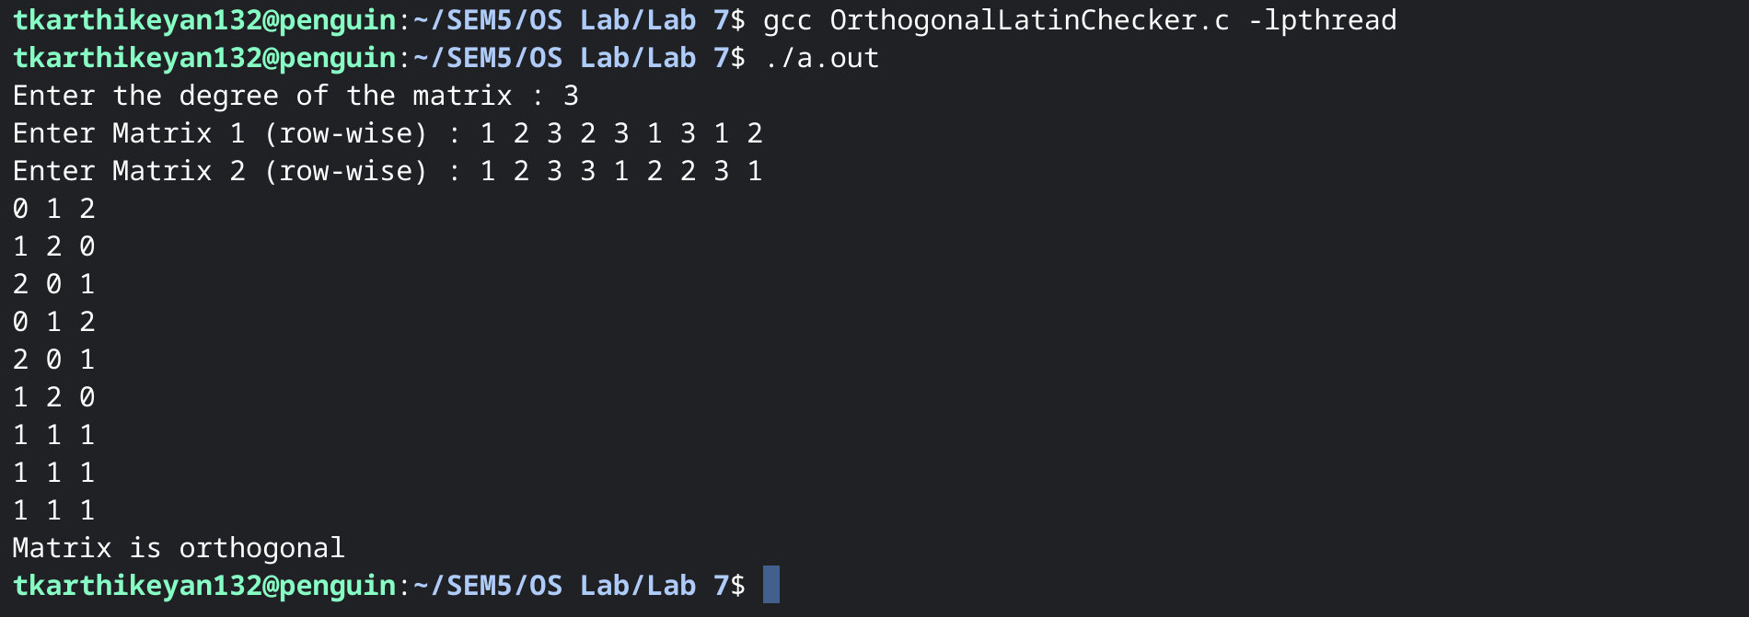

**OPERATING SYSTEMS**

**ASSIGNMENT 8**

**NAME : T Karthikeyan**

**ROLL : CED18I064**

**All my codes can be found here** [**CLICK HERE**](https://drive.google.com/drive/folders/1VFwT9s5UjlTyY3Tkyms_3pdwMRd3NMG7?usp=sharing)

1. **Dining Philosophers Problem**

**PROBLEM**

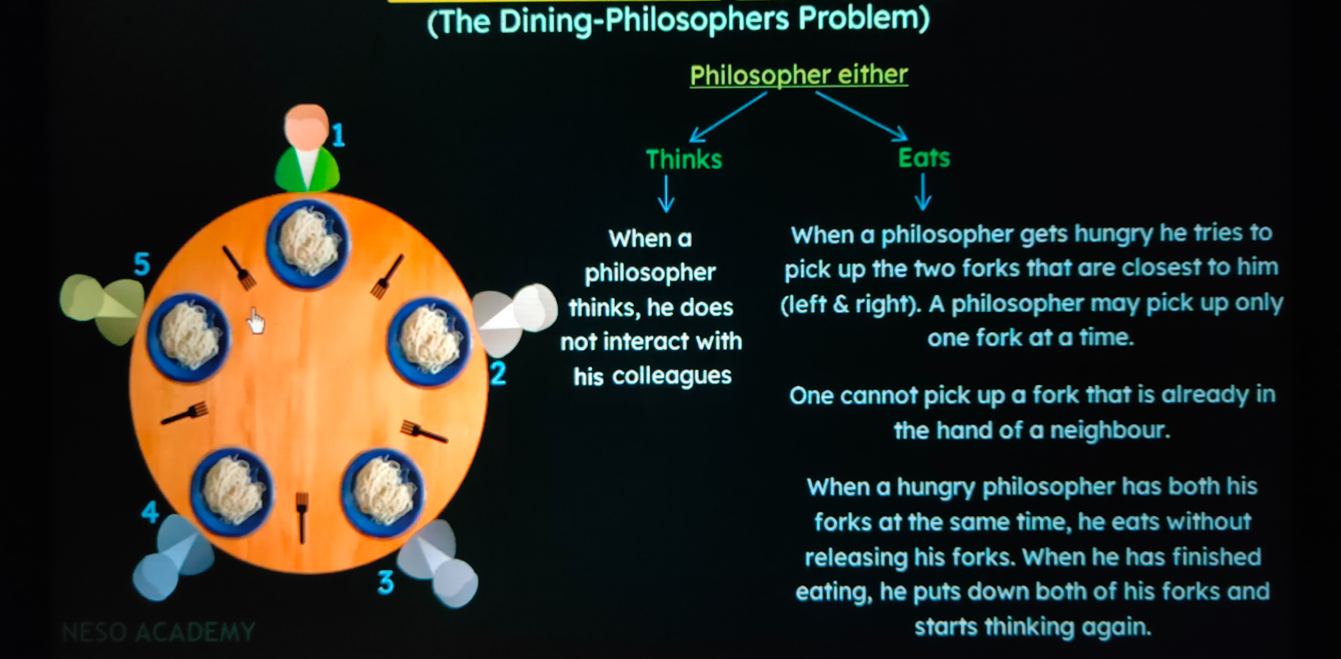

**WORKING**

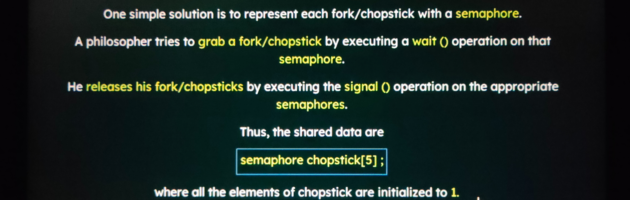

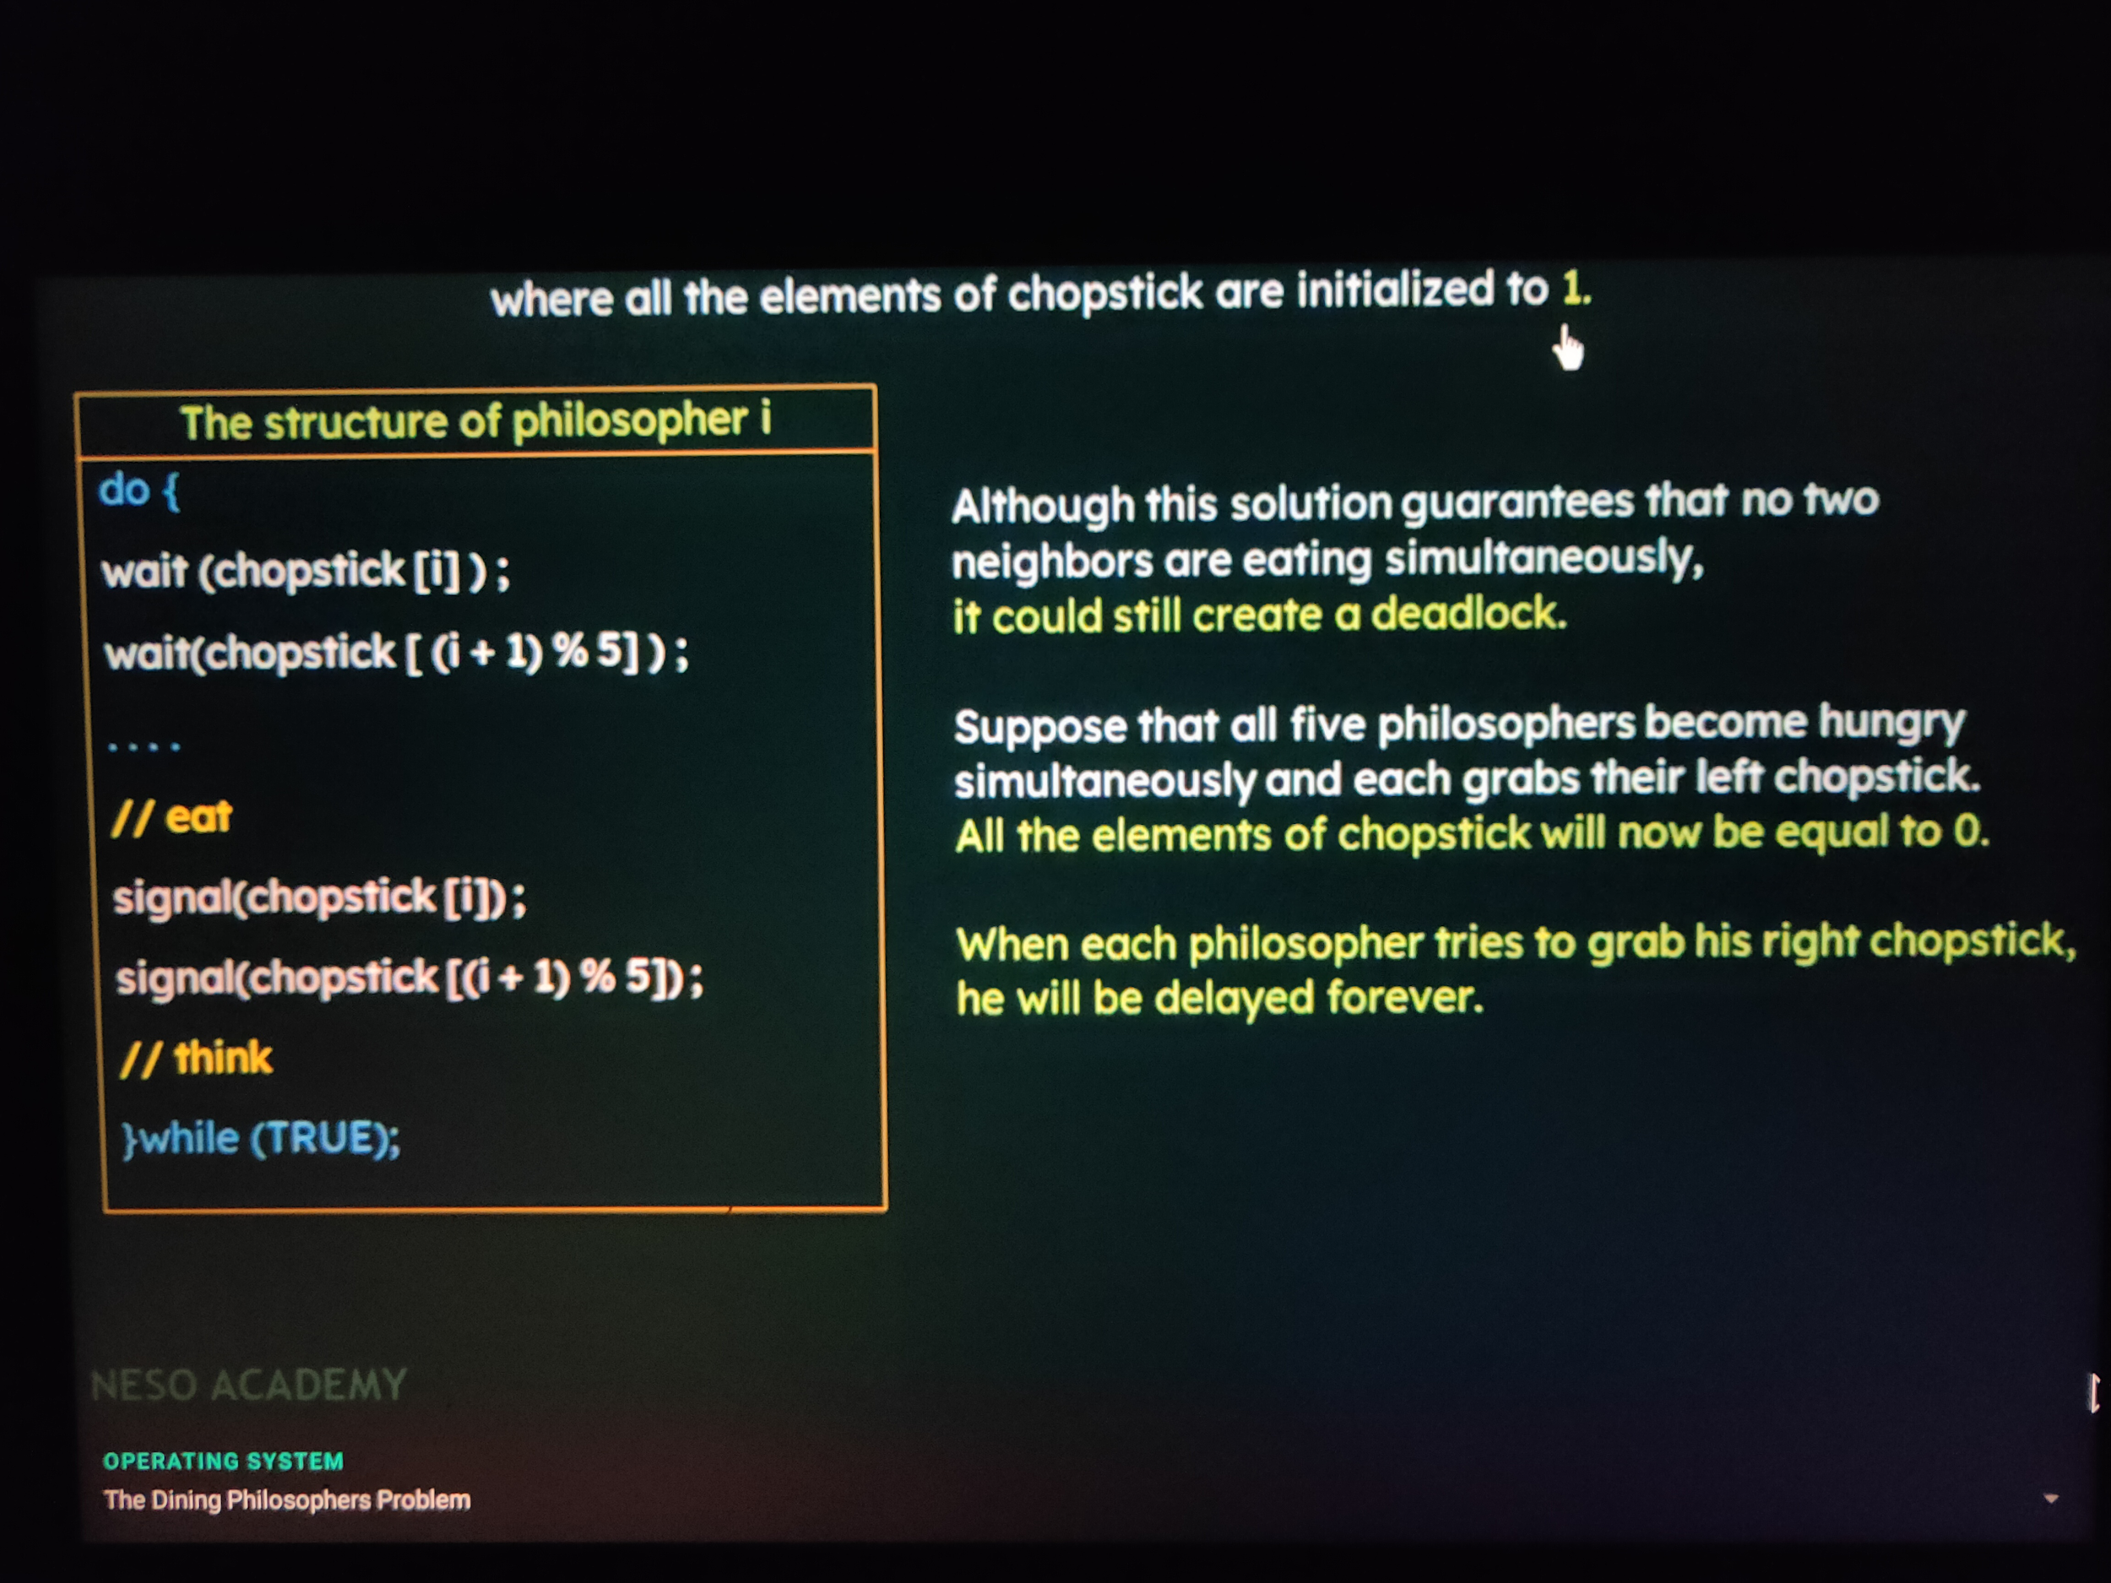

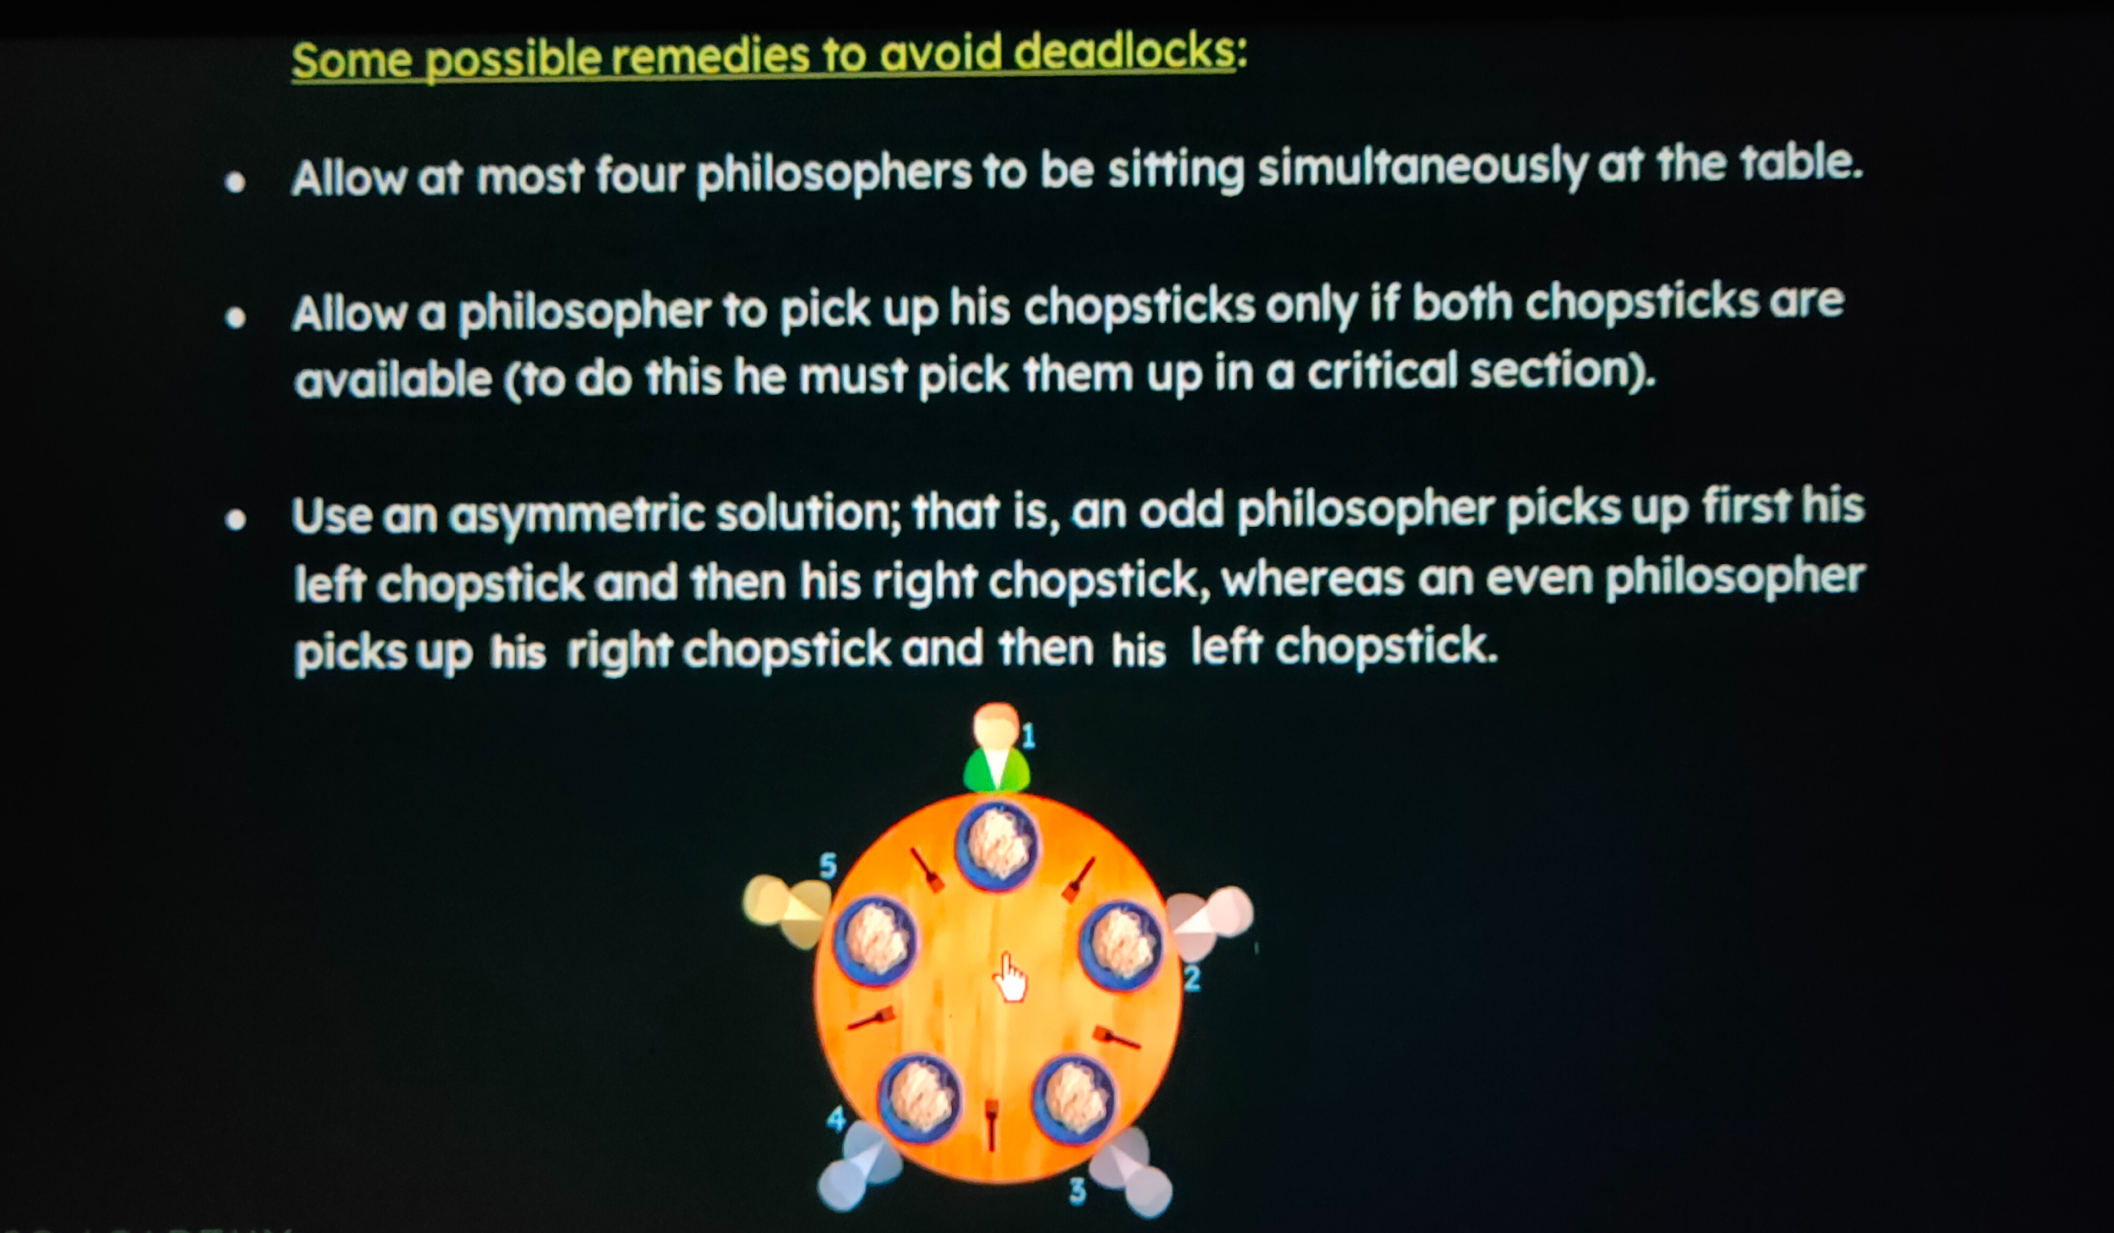

*We will be allowing the philosopher to pick up fork/chopstick only when both are available*

**CODE**

**#include<stdio.h>**

**#include<semaphore.h>**

**#include<pthread.h>**

**#define N 5**

**#define THINKING 0**

**#define HUNGRY 1**

**#define EATING 2**

**#define LEFT (ph_num+4)%N**

**#define RIGHT (ph_num+1)%N**

**sem_t mutex;**

**sem_t S[N];**

**void *philosopher(void *num);**

**void take_fork(int);**

**void put_fork(int);**

**void test(int);**

**int state[N];**

**int phil_num[N] = {0, 1, 2, 3, 4};**

**int main()**

**{**

**int i;**

**pthread_t thread_id[N];**

**sem_init(&mutex, 0, 1);**

**for(int i = 0; i < N; i++)**

**sem_init(&S[i], 0, 0);**

**for(int i = 0; i < N; i++)**

**{**

**pthread_create(&thread_id[i], NULL, philosopher, &phil_num[i]);**

**printf("Philosopher %d is thinking\n", i+1);**

**}**

**for(int i = 0; i < N; i++)**

**pthread_join(thread_id[i], NULL);**

**sem_destroy(&mutex);**

**for(int i = 0; i < N; i++)**

**sem_destroy(&S[i]);**

**return 0;**

**}**

**void *philosopher(void *num)**

**{**

**while(1)**

**{**

**int *i = num;**

**sleep(1);**

**take_fork(*i);**

**printf("Philosopher %d has finished eating\n", *i+1);**

**put_fork(*i);**

**}**

**}**

**void take_fork(int ph_num)**

**{**

**sem_wait(&mutex); // so that state update remains critical section**

**state[ph_num] = HUNGRY;**

**printf("Philosopher %d is Hungry\n", ph_num + 1);**

**test(ph_num);**

**sem_post(&mutex);**

**sem_wait(&S[ph_num]);**

**sleep(1);**

**}**

**void test(int ph_num)**

**{**

**if(state[ph_num] == HUNGRY && state[LEFT] != EATING && state[RIGHT] != EATING)**

**{**

**state[ph_num] = EATING;**

**sleep(2);**

**printf("Philosopher %d takes fork %d and %d\n", ph_num + 1, LEFT + 1, ph_num + 1);**

**printf("Philosopher %d is eating\n", ph_num + 1);**

**sem_post(&S[ph_num]);**

**}**

**}**

**void put_fork(int ph_num)**

**{**

**sem_wait(&mutex);**

**state[ph_num] = THINKING;**

**printf("Philosopher %d putting fork %d and %d down\n", ph_num + 1, LEFT + 1, ph_num + 1);**

**printf("Philosopher %d is thinking\n", ph_num + 1);**

**test(LEFT);**

**test(RIGHT);**

**sem_post(&mutex);**

**}**

**OUTPUT**

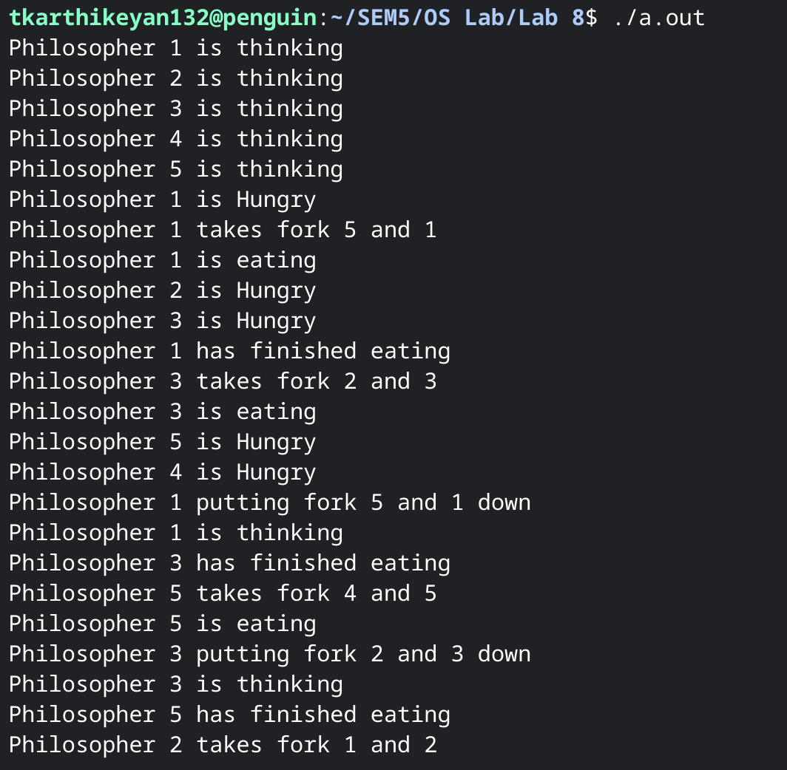

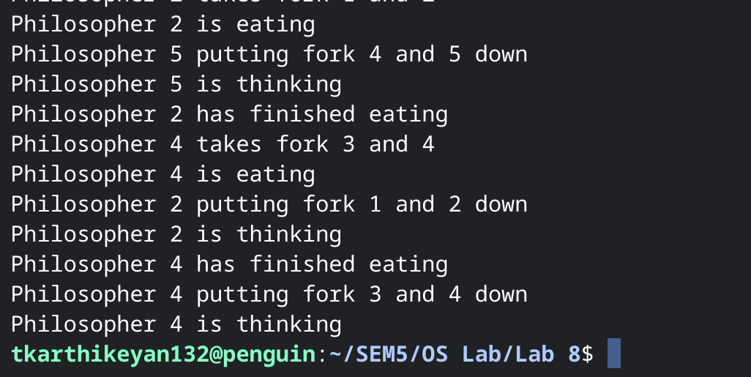

1. **Reader Writers Problem**

**PROBLEM**

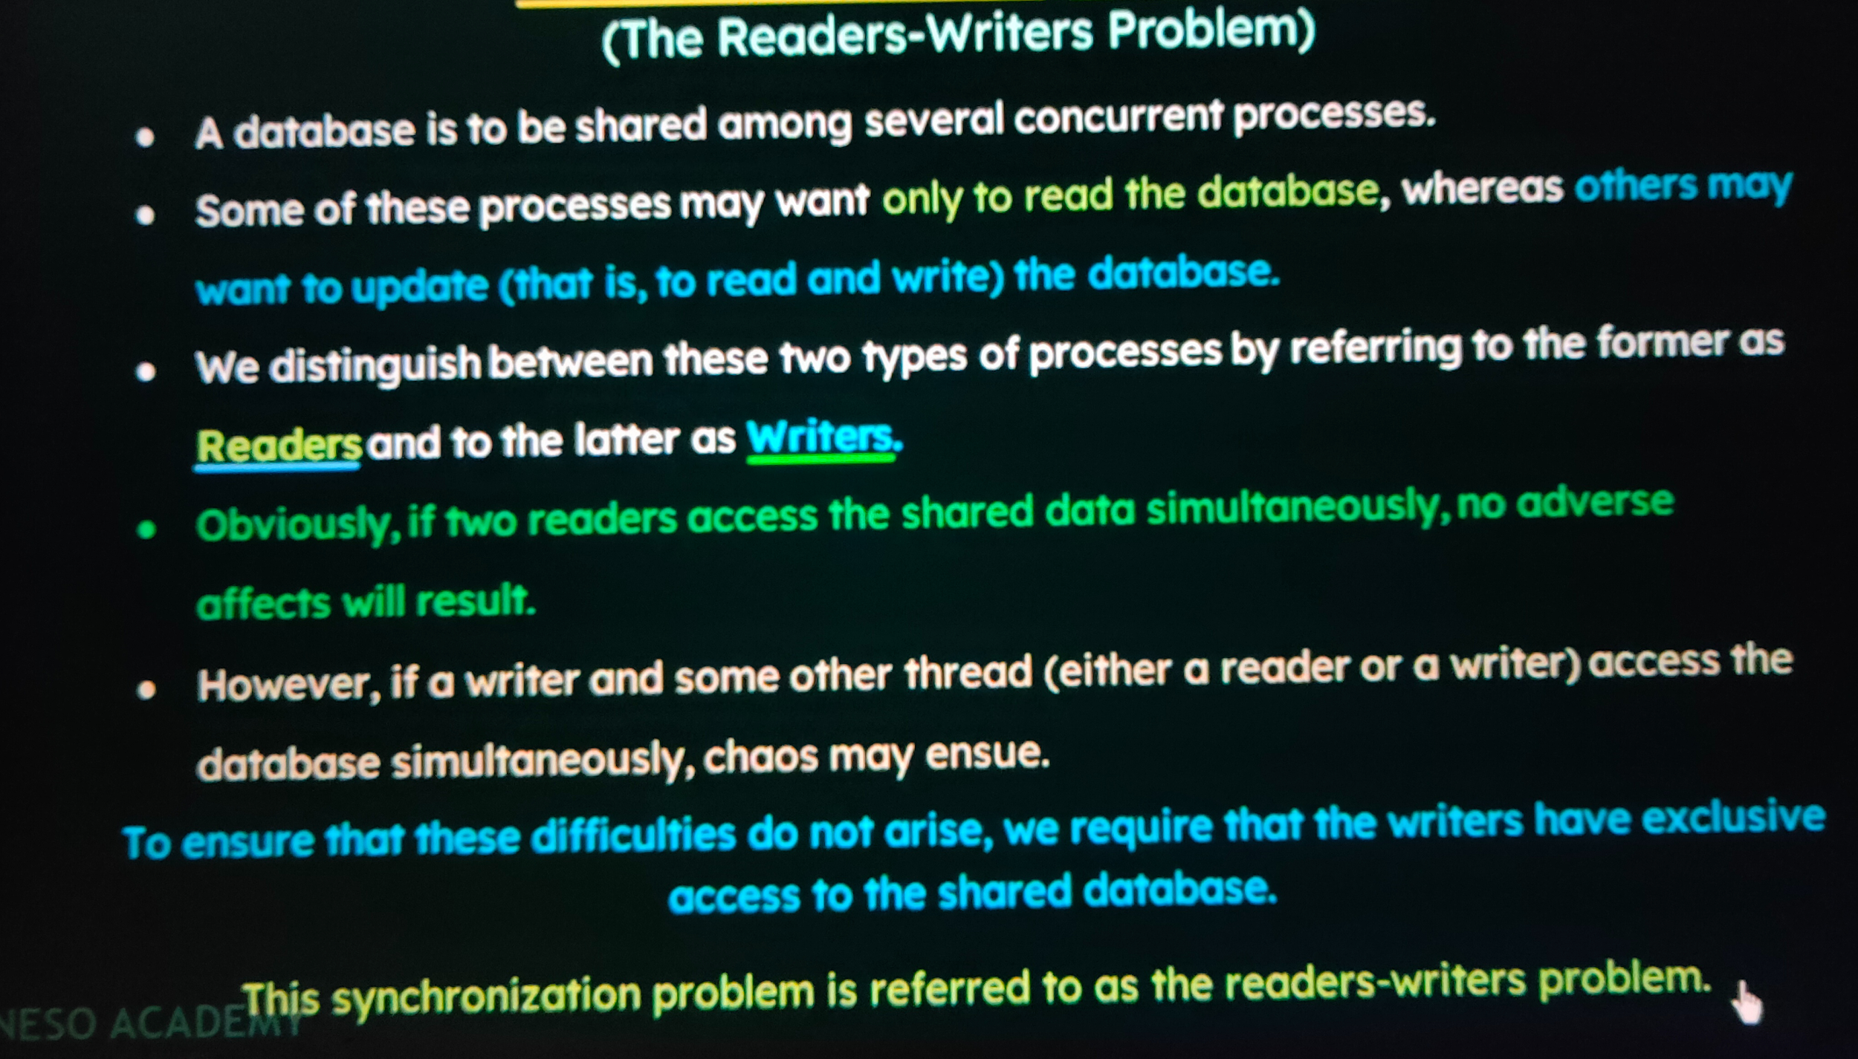

**WORKING**

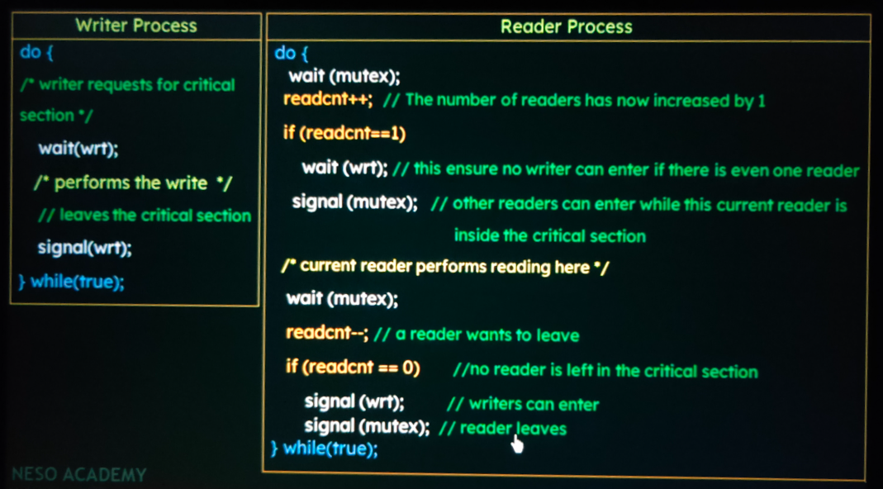

**CODE**

**#include<stdio.h>**

**#include<pthread.h>**

**#include<semaphore.h>**

**sem_t mutex, writeblock;**

**int data = 0, rcount = 0;**

**void *reader(void *arg);**

**void *writer(void *arg);**

**int main()**

**{**

**int i, b;**

**pthread_t rtid[3], wtid[3];**

**sem_init(&mutex, 0, 1);**

**sem_init(&writeblock, 0, 1);**

**int twid[3] = {0,1,2};**

**int trid[3] = {0,1,2};**

**// for(int i = 0; i <= 2; i++)**

**// {**

**pthread_create(&wtid[0], NULL, writer, &twid[0]);**

**pthread_create(&wtid[1], NULL, writer, &twid[1]);**

**pthread_create(&wtid[2], NULL, writer, &twid[2]);**

**pthread_create(&rtid[0], NULL, reader, &trid[0]);**

**pthread_create(&rtid[1], NULL, reader, &trid[1]);**

**pthread_create(&rtid[2], NULL, reader, &trid[2]);**

**// }**

**// for(int i = 0; i <= 2; i++)**

**// {**

**pthread_join(wtid[0], NULL);**

**pthread_join(rtid[0], NULL);**

**pthread_join(wtid[1], NULL);**

**pthread_join(rtid[1], NULL);**

**pthread_join(wtid[2], NULL);**

**pthread_join(rtid[2], NULL);**

**// }**

**sem_destroy(&mutex);**

**sem_destroy(&writeblock);**

**return 0;**

**}**

**void *reader(void *arg)**

**{**

**int *f;**

**f = arg;**

**sem_wait(&mutex);**

**rcount = rcount + 1;**

**if(rcount == 1) // first reader**

**sem_wait(&writeblock);**

**sem_post(&mutex);**

**printf("Data read by the reader %d is %d\n", *f, data);**

**sem_wait(&mutex);**

**rcount = rcount - 1;**

**if(rcount == 0) // last reader**

**sem_post(&writeblock);**

**sleep(3);**

**sem_post(&mutex);**

**}**

**void *writer(void *arg)**

**{**

**int *f;**

**f = arg;**

**sem_wait(&writeblock);**

**data++;**

**printf("Data written by the writer %d is %d\n", *f, data);**

**sleep(3);**

**sem_post(&writeblock);**

**}**

**OUTPUT**

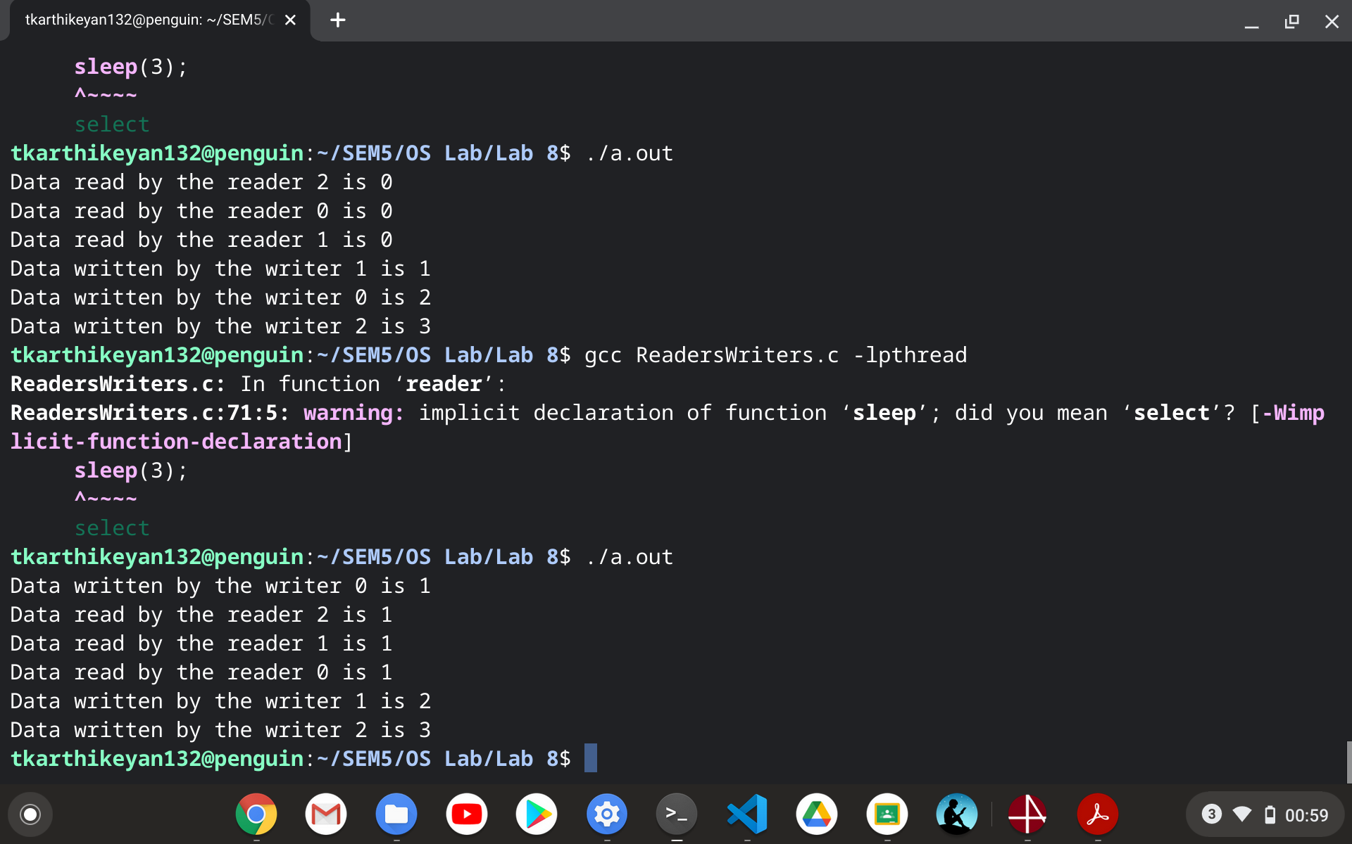

1. **Dining Hall Problem**

**PROBLEM**

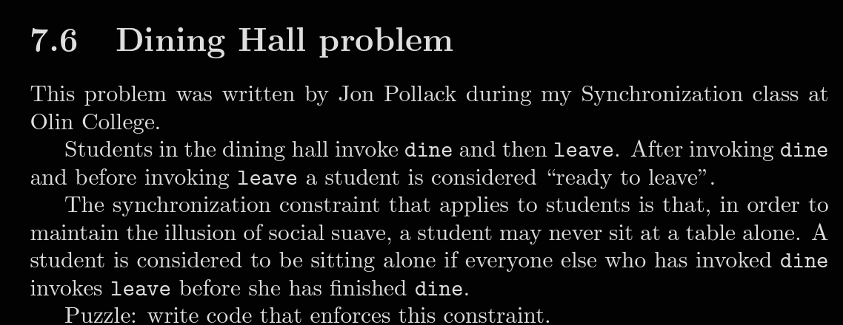

**PSEUDOCODE AND LOGIC**

*eating and readyToLeave are counters protected by mutex, so this is the usual scoreboard pattern. If a student is ready to leave, but another student would be left alone at the table, she waits on okToLeave until another student changes the situation and signals.*

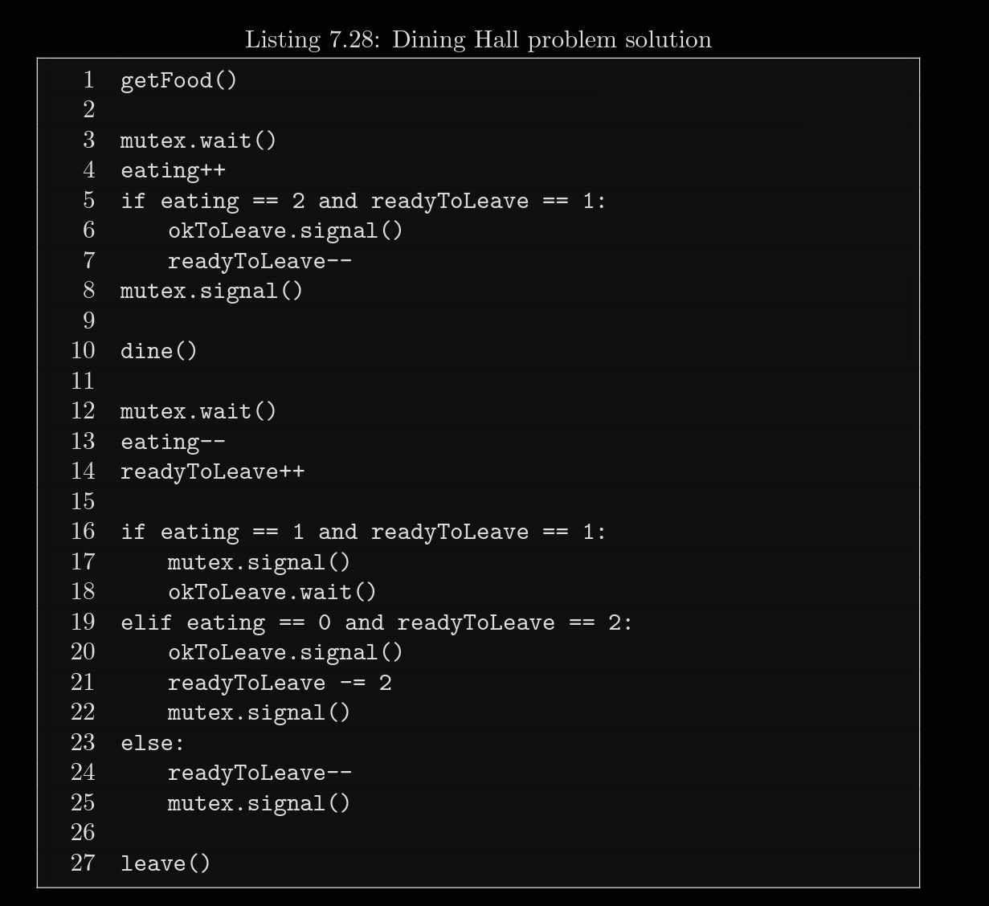

*When a student is checking in, if she sees one student eating and one waiting to leave, she lets the waiter off the hook and decrements readyToLeave for him.*

*After dining, the student checks three cases:*

*• If there is only one student left eating, the departing student has to give up the mutex and wait.*

*• If the departing student finds that someone is waiting for her, she signals him and updates the counter for both of them.*

*• Otherwise, she just decrements readyToLeave and leaves.*

**CODE**

**#include<stdlib.h>**

**#include<stdio.h>**

**#include<stdbool.h>**

**#include<pthread.h>**

**#include<semaphore.h>**

**#define DINING_CAPACITY 5**

**int eating = 0;**

**int readyToLeave = 0;**

**sem_t mutex, okToLeave;**

**void *dine(void *param);**

**int main()**

**{**

**pthread_t tid[DINING_CAPACITY];**

**sem_init(&mutex, 0, 1);**

**sem_init(&okToLeave, 0, 0);**

**int tempid[DINING_CAPACITY];**

**for(int i = 0; i < DINING_CAPACITY; i++)**

**tempid[i] = i + 1;**

**for(int i = 0; i < DINING_CAPACITY; i++)**

**pthread_create(&tid[i], NULL, dine, &tempid[i]);**

**for(int i = 0; i < DINING_CAPACITY; i++)**

**pthread_join(tid[i], NULL);**

**sem_destroy(&mutex);**

**sem_destroy(&okToLeave);**

**return 0;**

**}**

**void *dine(void *param)**

**{**

**int *f = param;**

**printf("Diner %d entered the dining hall\n", *f);**

**sem_wait(&mutex);**

**eating++;**

**printf("Diner %d is eating\n", *f);**

**if(eating == 2 && readyToLeave == 1)**

**{**

**sem_post(&okToLeave);**

**readyToLeave--;**

**}**

**sem_post(&mutex);**

**sleep(5);**

**sem_wait(&mutex);**

**eating--;**

**readyToLeave++;**

**printf("Diner %d is ready to leave\n", *f);**

**if(eating == 1 && readyToLeave == 1)**

**{**

**sem_post(&mutex);**

**sem_wait(&okToLeave);**

**}**

**else if(eating == 0 && readyToLeave == 2)**

**{**

**sem_post(&okToLeave);**

**readyToLeave-=2;**

**sem_post(&mutex);**

**}**

**else**

**{**

**readyToLeave--;**

**sem_post(&mutex);**

**}**

**printf("Diner %d has left the hall\n", *f);**

**}**

**OUTPUT**

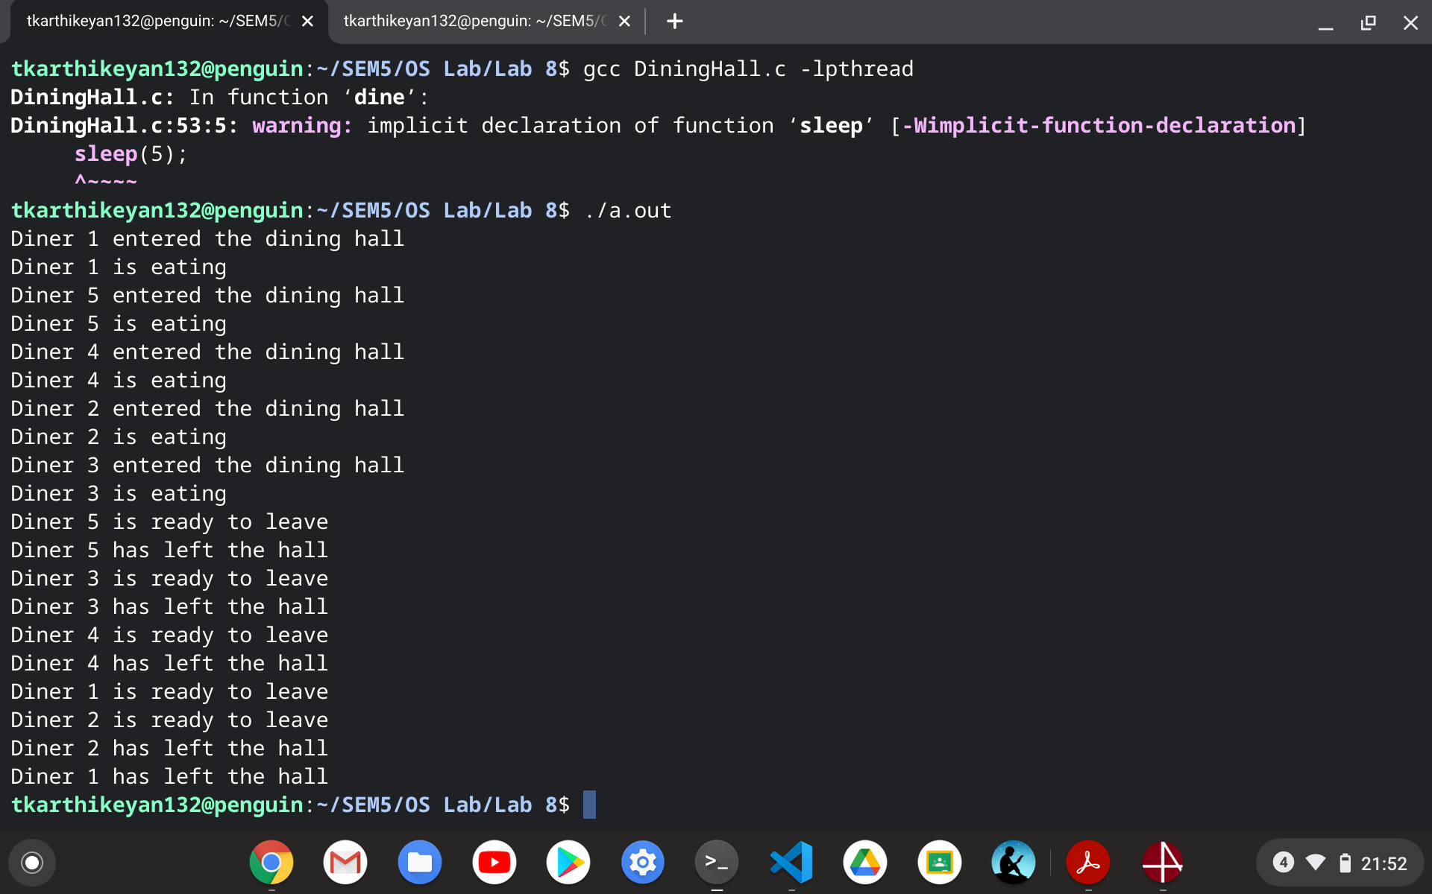

1. **SENATE BUS PROBLEM**

**PROBLEM**

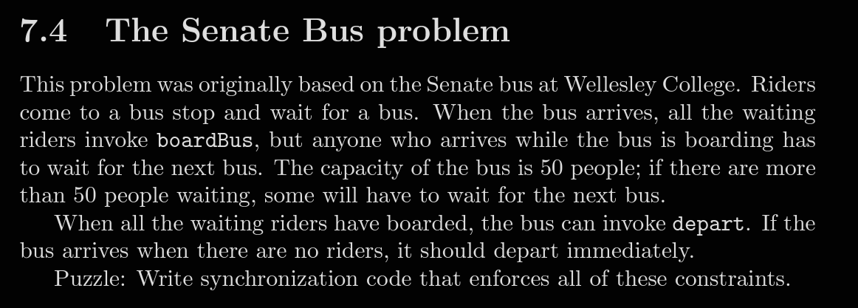

**PSEUDOCODE AND LOGIC**

*mutex protects riders, which keeps track of how many riders are waiting; multiplex makes sure there are no more than 50 riders in the boarding area. Riders wait on the bus, which gets signaled when the bus arrives. The bus waits on allAboard, which gets signaled by the last student to board.*

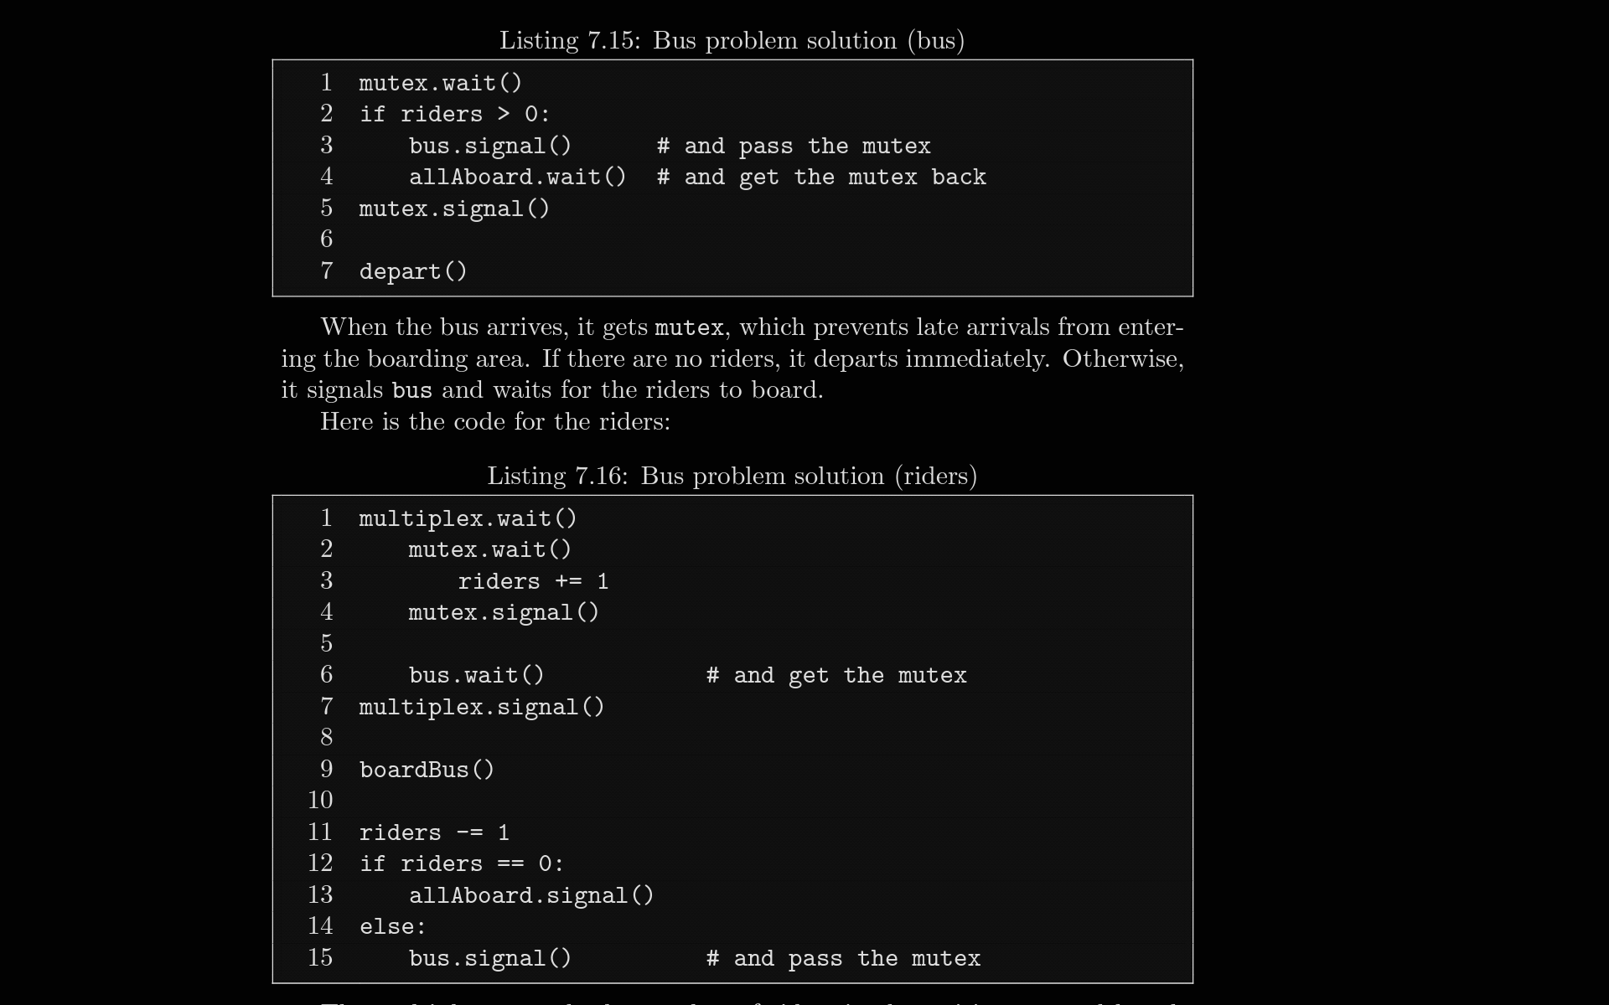

*The multiplex controls the number of riders in the waiting area, although strictly speaking, a rider doesn’t enter the waiting area until she increments riders. Riders wait on the bus until the bus arrives. When a rider wakes up, it is understood that she has the mutex. After boarding, each rider decrements riders. If there are more riders waiting, the boarding rider signals the bus and passes the mutex to the next rider. The last rider signals allAboard and passes the mutex back to the bus. Finally, the bus releases the mutex and departs.*

**CODE**

**#include<stdlib.h>**

**#include<stdio.h>**

**#include<stdbool.h>**

**#include<pthread.h>**

**#include<semaphore.h>**

**#define BUS_CAPACITY 10**

**#define NUM_BUSES 2**

**#define NUM_PASSENGERS 28**

**void *Bus(void *param);**

**void *rider(void *param);**

**int riders = 0; //number of riders waiting in the bus stop**

**sem_t mutex, multiplex, bus, allAboard;**

**int main()**

**{**

**pthread_t pid[NUM_PASSENGERS];**

**pthread_t bid[NUM_BUSES];**

**sem_init(&mutex, 0, 1);**

**sem_init(&multiplex, 0, BUS_CAPACITY);**

**sem_init(&bus, 0, 0);**

**sem_init(&allAboard, 0, 0);**

**int temppid[NUM_PASSENGERS];**

**for(int i = 0; i < NUM_PASSENGERS; i++)**

**temppid[i] = i + 1;**

**int tempbid[NUM_BUSES];**

**for(int i = 0; i < NUM_BUSES; i++)**

**tempbid[i] = i + 1;**

**for(int i = 0; i < NUM_PASSENGERS; i++)**

**pthread_create(&pid[i], NULL, rider, &temppid[i]);**

**for(int i = 0; i < NUM_BUSES; i++)**

**pthread_create(&bid[i], NULL, Bus, &tempbid[i]);**

**for(int i = 0; i < NUM_PASSENGERS; i++)**

**pthread_join(pid[i], NULL);**

**for(int i = 0; i < NUM_BUSES; i++)**

**pthread_join(bid[i], NULL);**

**sem_destroy(&mutex);**

**sem_destroy(&multiplex);**

**sem_destroy(&bus);**

**sem_destroy(&allAboard);**

**return 0;**

**}**

**void *Bus(void *param)**

**{**

**int *f = param;**

**sem_wait(&mutex);**

**if(riders > 0)**

**{**

**sem_post(&bus);**

**sem_wait(&allAboard);**

**}**

**sem_post(&mutex);**

**printf("Bus %d departed from the bus stop\n", *f);**

**}**

**void *rider(void *param)**

**{**

**int *f = param;**

**sem_wait(&multiplex);**

**sem_wait(&mutex);**

**riders+=1;**

**sem_post(&mutex);**

**sem_wait(&bus);**

**sem_post(&multiplex);**

**printf("rider %d is boarding the bus\n", *f);**

**sleep(2);**

**riders -= 1;**

**if(riders == 0)**

**sem_post(&allAboard);**

**else**

**sem_post(&bus);**

**printf("rider %d boarded the bus\n", *f);**

**}**

**OUTPUT**

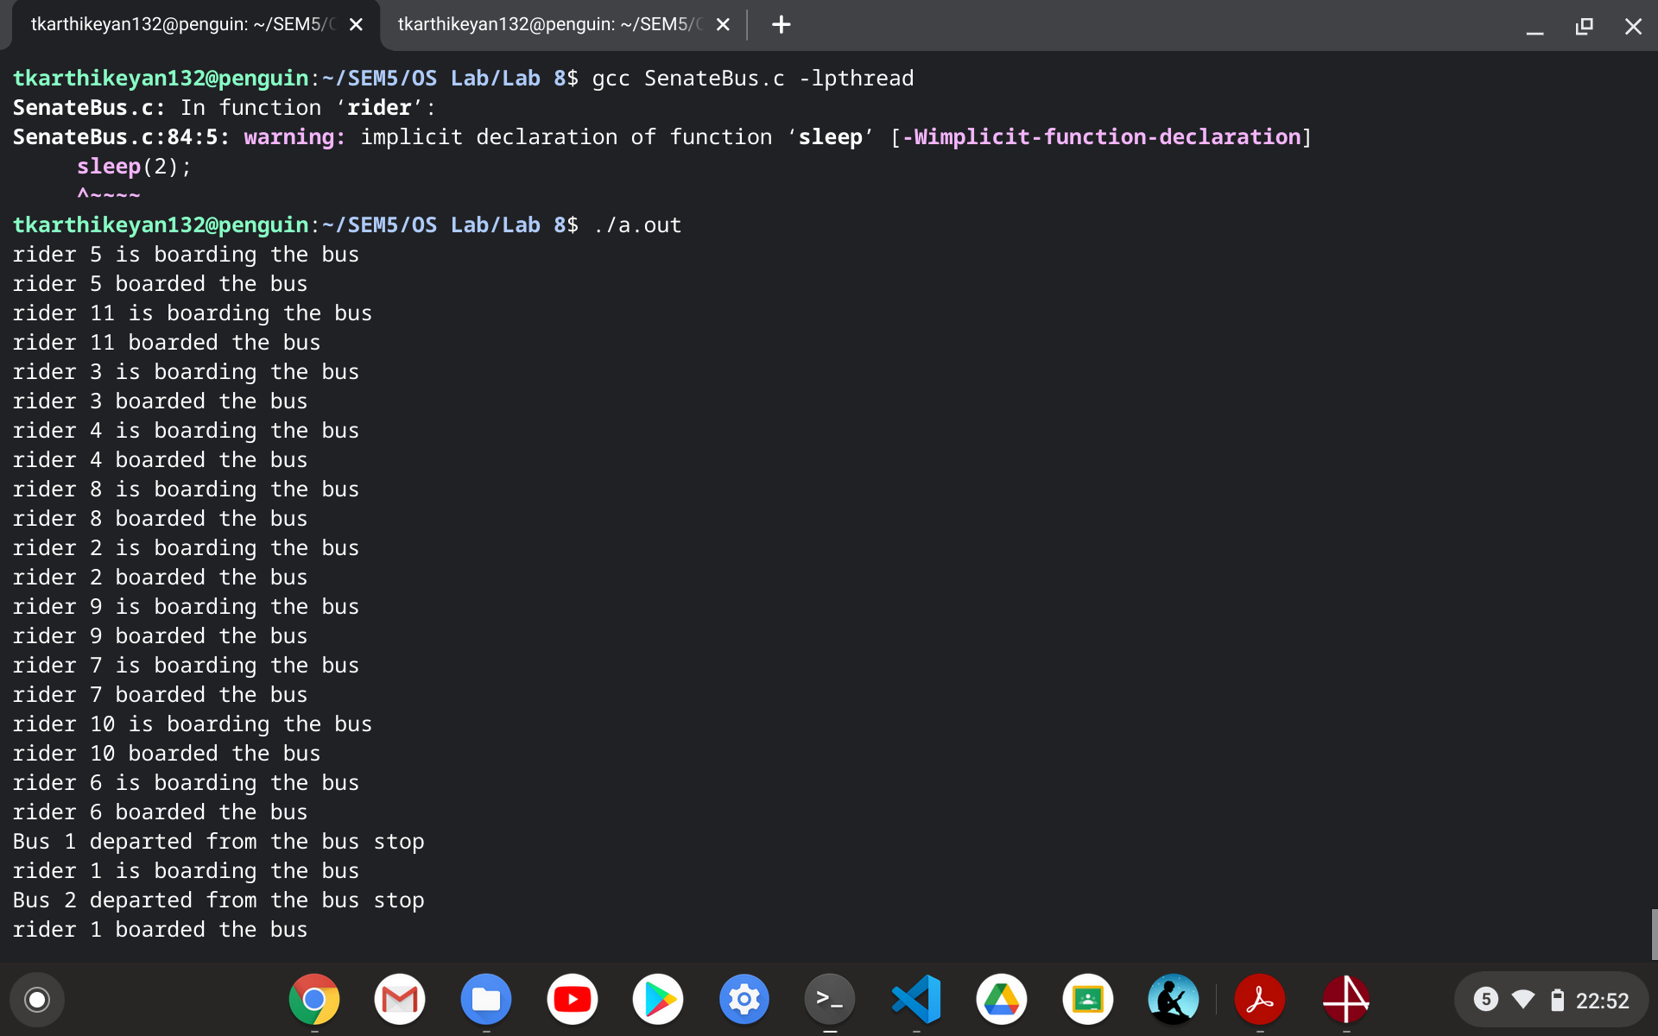

**Thanks**